**2018 PEW RESEARCH CENTER’S AMERICAN TRENDS PANEL**

**WAVE 31 FEBRUARY 2018**

**JANUARY 29-FEBRUARY 13, 2018[1]**

Base: ASK ALL

**SATISF [S]**

All in all, are you satisfied or dissatisfied with the way things are going in this country today?

1 Satisfied

2 Dissatisfied

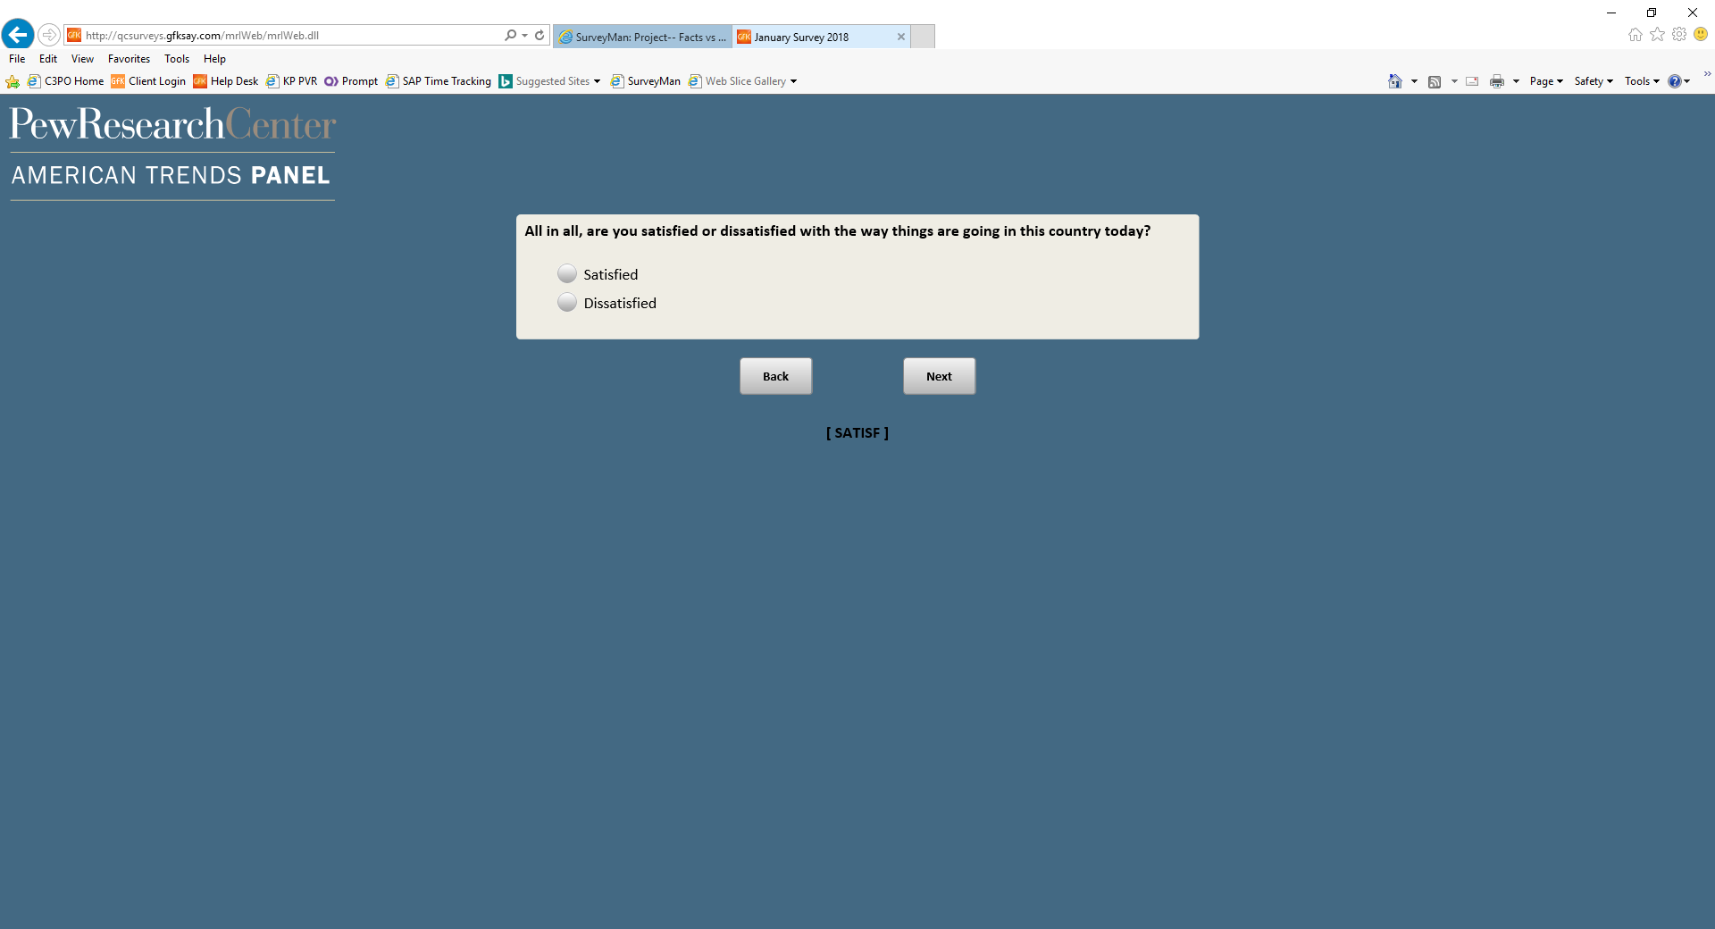

Base: ASK ALL

***Scripter: Show CONFa-f on the same screen.***

***Scripter: Randomize and record items a-f***

**CONF [S]**

How much confidence, if any, do you have in each of the following to act in the best interests of the public?

1. Elected officials

1 A great deal of confidence

2 A fair amount of confidence

3 Not too much confidence

4 No confidence at all

1. The news media

1 A great deal of confidence

2 A fair amount of confidence

3 Not too much confidence

4 No confidence at all

1. The military

1 A great deal of confidence

2 A fair amount of confidence

3 Not too much confidence

4 No confidence at all

1. Religious leaders

1 A great deal of confidence

2 A fair amount of confidence

3 Not too much confidence

4 No confidence at all

1. Business leaders

1 A great deal of confidence

2 A fair amount of confidence

3 Not too much confidence

4 No confidence at all

1. Scientists

1 A great deal of confidence

2 A fair amount of confidence

3 Not too much confidence

4 No confidence at all

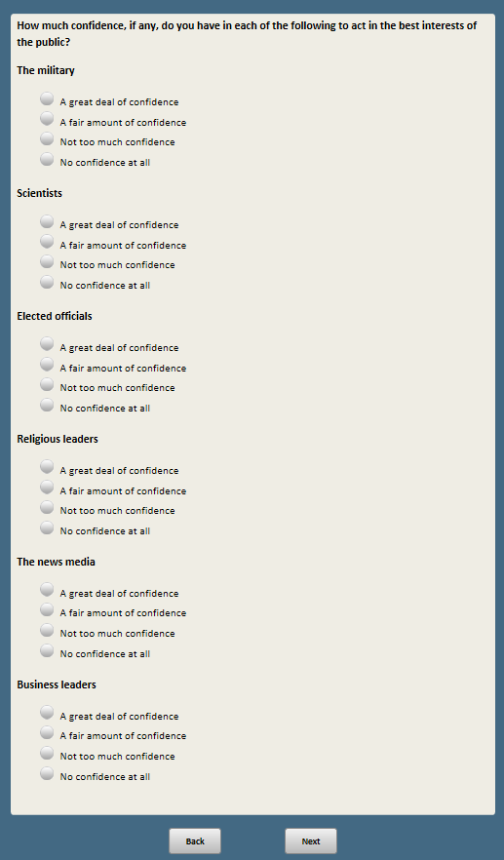 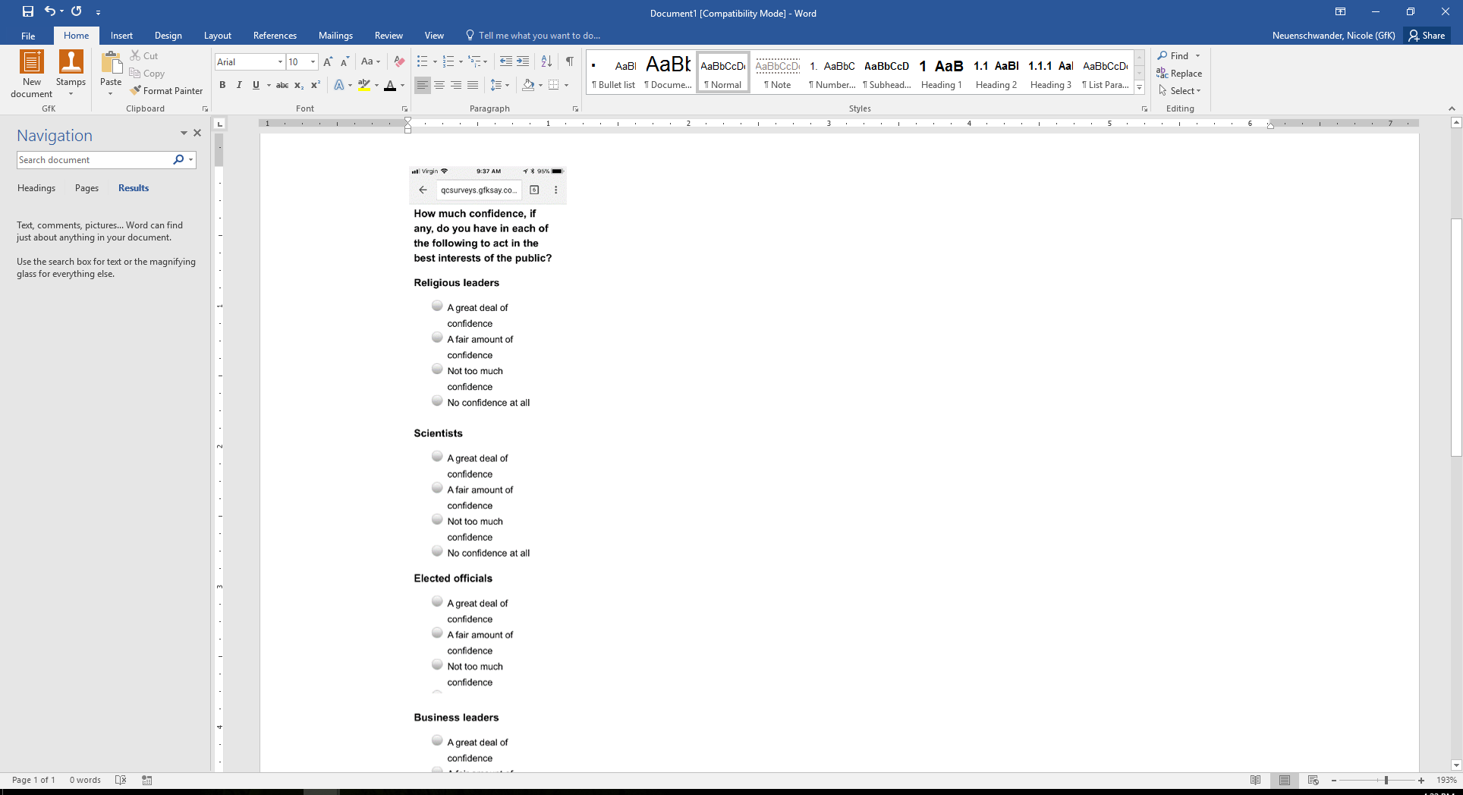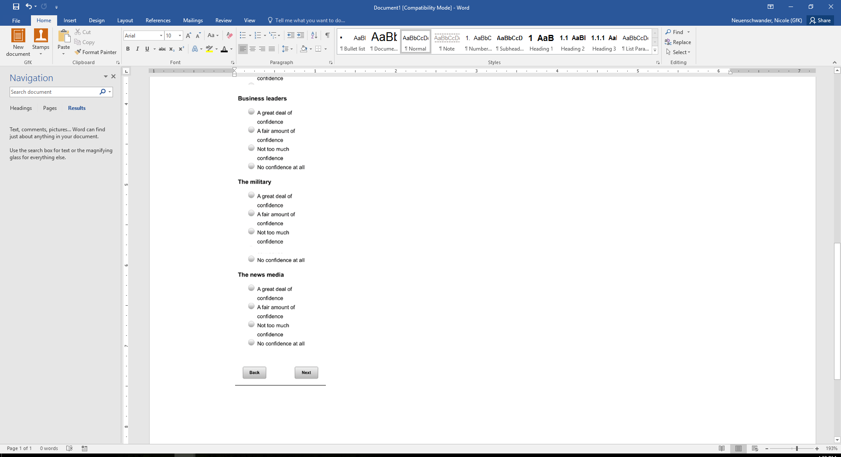

Base: ASK ALL

**POL1DT [S]**

Do you approve or disapprove of the way Donald Trump is handling his job as President?

1 Approve

2 Disapprove

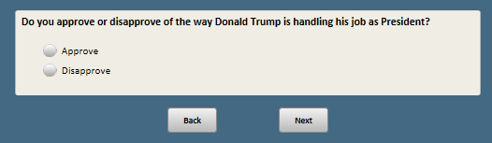

Base: POL1DT=1 or 2 (ASK IF ANSWERED POL1DT)

**POL1DTSTR [S]**

Do you **[IF POL1DT=1:** approve**; IF POL1DT=2:** disapprove**]** of the way Donald Trump is handling his job as President…

1 Very strongly

2 Not so strongly

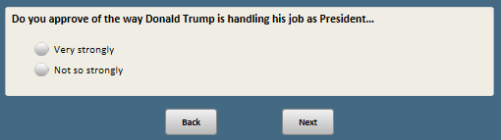

Base: ASK ALL

**FOLGOV [S]**

Would you say you follow what’s going on in government and public affairs…

1 Most of the time

2 Some of the time

3 Only now and then

4 Hardly at all

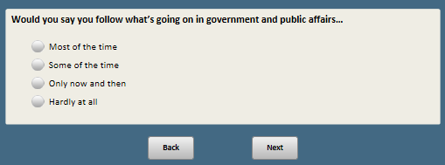

Base: ASK ALL

**OFTVOTE [S]**

How often would you say you vote?

1 Always

2 Nearly always

3 Part of the time

4 Seldom

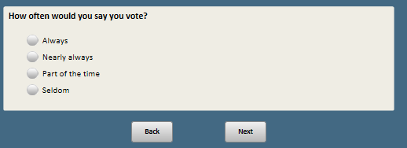

Base: ASK ALL

*Scripter: PLEASE FLIP THE RESPONSE LABELS FOR HALF OF RESPONDENTS LEAVING THE SCALE ALWAYS 1🡪4; CAPTURE RANDOMIZATION; WE MAY WANT TO PROGRAM PEOPLE TO RECEIVE SAME RANDOMIZATION IN THE FUTURE*

**MATTERSCONG [S]**

Thinking about how you feel about the 2018 congressional election, where would you place yourself on the following scale?

1 1 = Really matters which party wins control of Congress

2 2

3 3

4 4 = Doesn’t really matter which party wins control of Congress

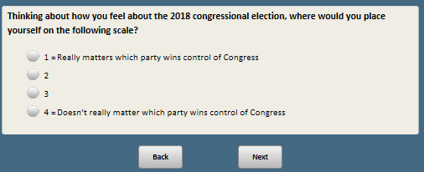

Base: Ask if not living in DC

*Scripter: Randomize and record response options 1 and 2*

**CONG [S]**

If the elections for the U.S. House of Representatives were being held TODAY, who would you vote for?

1 The Republican Party’s candidate

2 The Democratic Party’s candidate

3 Another candidate

4 Not sure

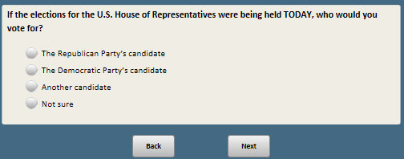

Base: Ask if not living in DC AND (CONG=4 or 99 (not sure or refused))

*Scripter: show in same order as CONG*

**CONGA [S]**

As of TODAY, who do you LEAN more to for the U.S. House of Representatives?

1 Lean to the Republican Party’s candidate

2 Lean to the Democratic Party’s candidate

3 Lean to another candidate

4 Not sure

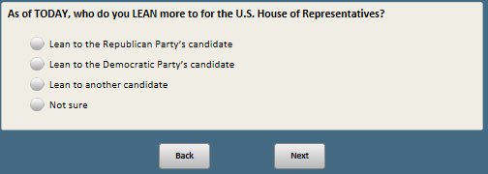

Base: ASK ALL

**TALKPOL [S]**

Now, thinking about the people you talk with, whether in person, over the phone, or electronically…

How often do you discuss government and politics with others?

1. Nearly every day
2. A few times a week
3. A few times a month
4. Less often

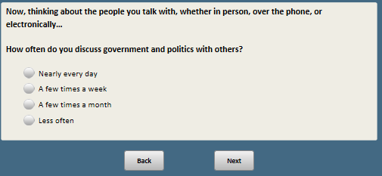

Base: ASK ALL

*Scripter: Randomize and record response order*

**COREUSDEM [S]**

Thinking about the fundamental design and structure of American government, which comes closer to your view?

1 Significant changes to the design and structure are needed to make it work for current times

2 The design and structure serves the country well and does not need significant changes

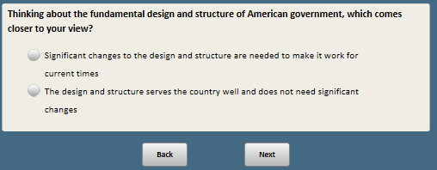

Base: ASK ALL

***Scripter: Split IMPTUS into two screens, with random order***

***Scripter: Randomize and record items a-h***

**IMPTUS [S]**

Now we’re going to ask you about the importance of a number of things for the United States.

For each of the following, HOW IMPORTANT is it for the country that…

a. Government policies generally reflect the views of most Americans

1 Very important

2 Somewhat important

3 Not too important

4 Not at all important

b. The government conducts its work openly and transparently

1 Very important

2 Somewhat important

3 Not too important

4 Not at all important

c. The executive, legislative and judicial branches of government each keep the others from having too much power

1 Very important

2 Somewhat important

3 Not too important

4 Not at all important

d. People who give a lot of money to elected officials do not have more political influence than other people

1 Very important

2 Somewhat important

3 Not too important

4 Not at all important

e. The tone of debate among political leaders is respectful

1 Very important

2 Somewhat important

3 Not too important

4 Not at all important

f. Republican and Democratic elected officials work together on important issues

1 Very important

2 Somewhat important

3 Not too important

4 Not at all important

g. Elected officials face serious consequences if they engage in misconduct

1 Very important

2 Somewhat important

3 Not too important

4 Not at all important

h. Judges are not influenced by political parties

1 Very important

2 Somewhat important

3 Not too important

4 Not at all important

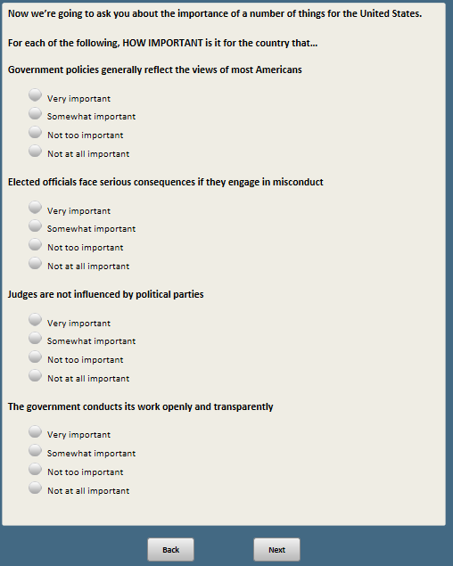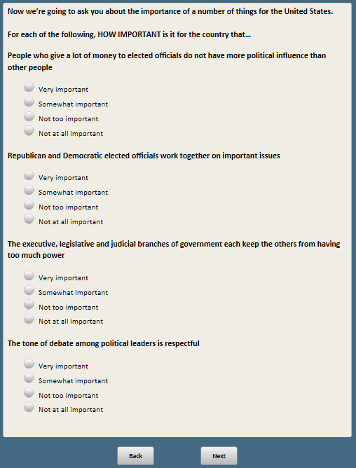

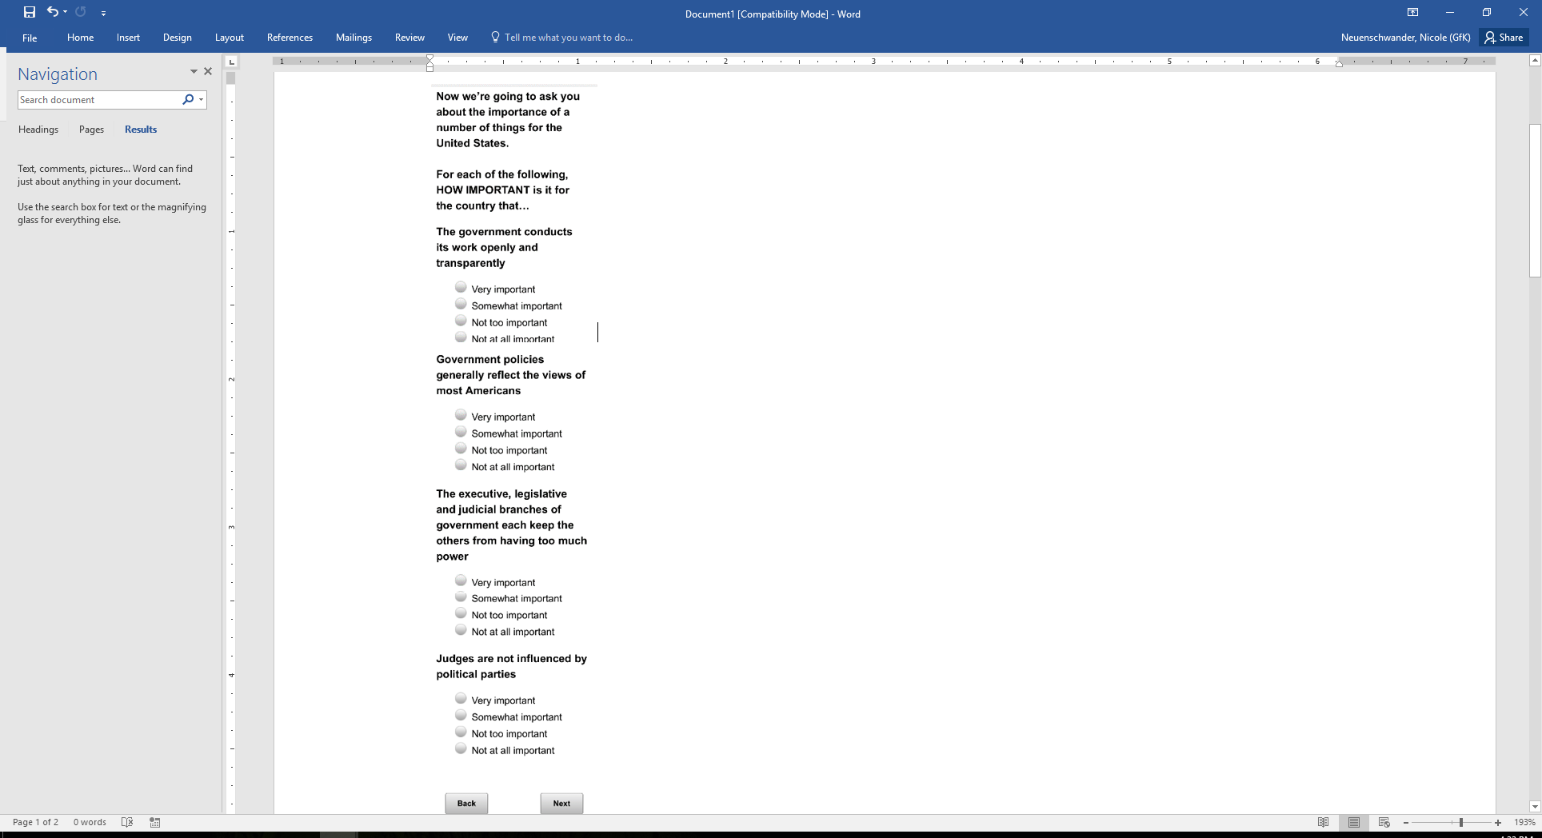 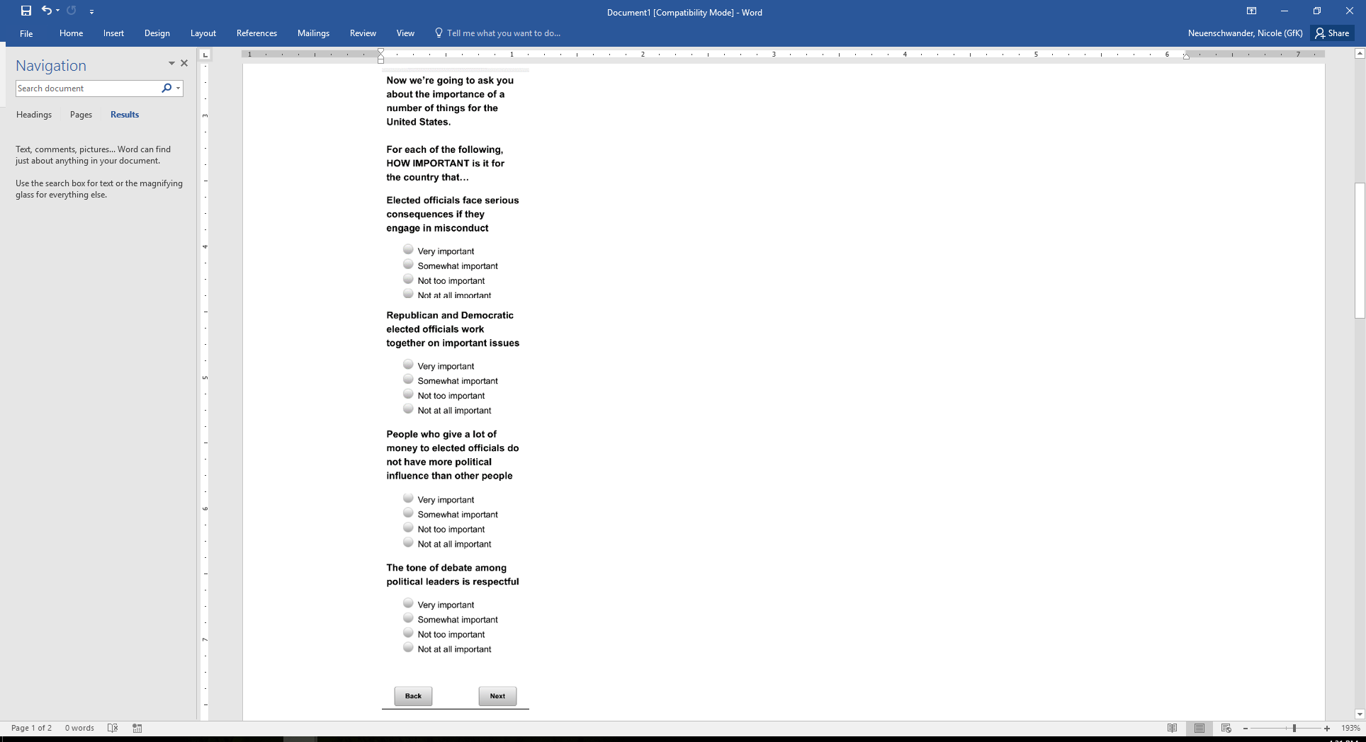

Base: ASK ALL

***Scripter: Split into two screens.***

***Scripter: Show in same order as IMPTUS***

**WELLUS [S]**

Now thinking about how things actually are in the U.S. today, HOW WELL does each of the following describe the country?

a. Government policies generally reflect the views of most Americans

1 Very well

2 Somewhat well

3 Not too well

4 Not at all well

b. The government conducts its work openly and transparently

1 Very well

2 Somewhat well

3 Not too well

4 Not at all well

c. The executive, legislative and judicial branches of government each keep the others from having too much power

1 Very well

2 Somewhat well

3 Not too well

4 Not at all well

d. People who give a lot of money to elected officials do not have more political influence than other people

1 Very well

2 Somewhat well

3 Not too well

4 Not at all well

e. The tone of debate among political leaders is respectful

1 Very well

2 Somewhat well

3 Not too well

4 Not at all well

f. Republican and Democratic elected officials work together on important issues

1 Very well

2 Somewhat well

3 Not too well

4 Not at all well

1. Elected officials face serious consequences if they engage in misconduct

1 Very well

2 Somewhat well

3 Not too well

4 Not at all well

h. Judges are not influenced by political parties

1 Very well

2 Somewhat well

3 Not too well

4 Not at all well

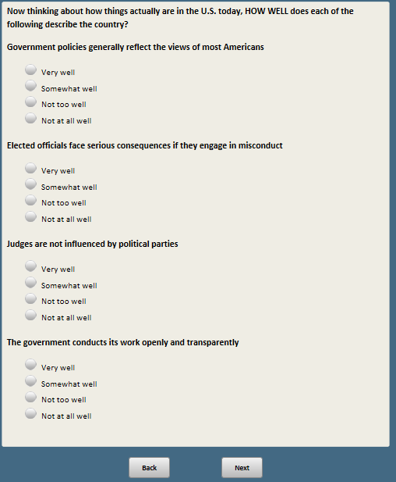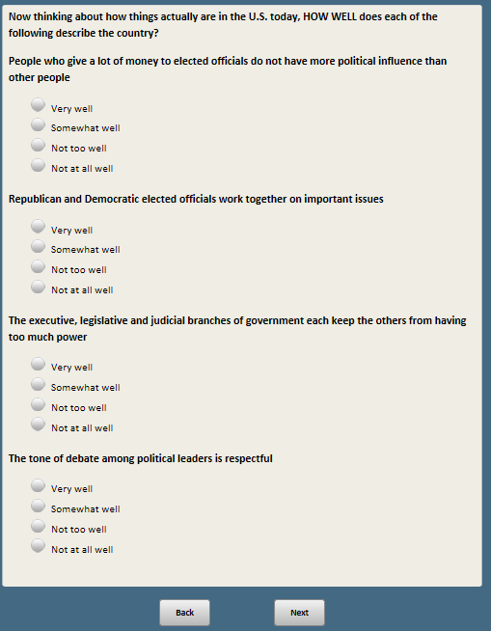

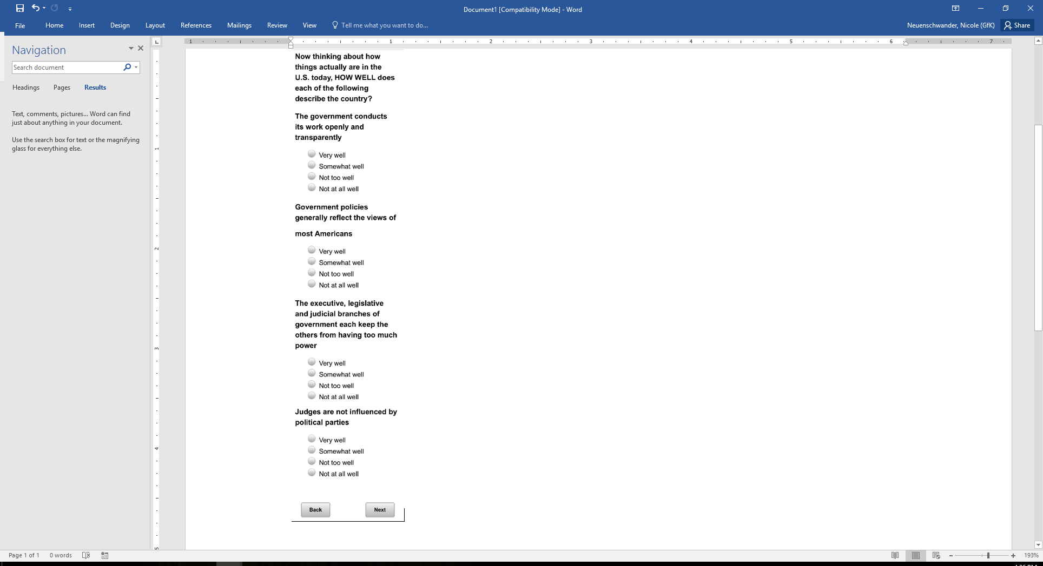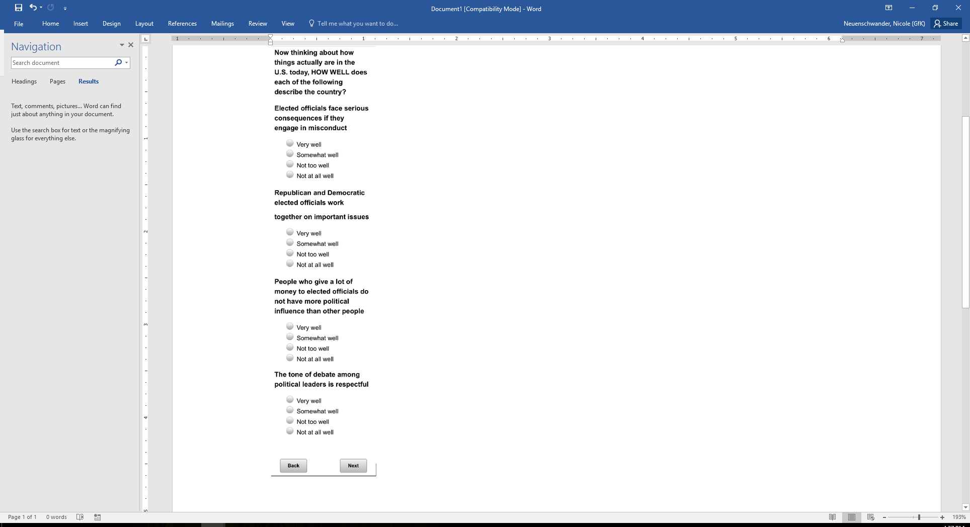

Base: xform=1 (ASK FORM 1)

*Scripter: Randomize and record response order*

**GOVVOTEREP [S]**

Thinking about a new bill passed in a state with a Republican governor…

If most people in the state support the bill, but most Republicans in the state oppose it, what should the governor do?

1. Sign the bill
2. Veto the bill

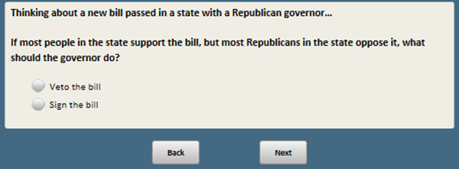

Base: xform=3 (ASK FORM 3)

*Scripter: Randomize and record response order*

**GOVVOTEDEM [S]**

Thinking about a new bill passed in a state with a Democratic governor…

If most people in the state support the bill, but most Democrats in the state oppose it, what should the governor do?

1. Sign the bill
2. Veto the bill

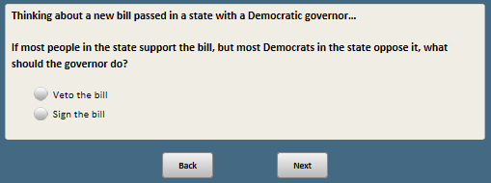

Base: xform=2 (ASK FORM 2)

*Scripter: Randomize and record response order*

**GOVVOTEGEN [S]**

Thinking about a new bill passed in a state…

If most people in the state support the bill, but most people who voted for the governor oppose it, what should the governor do?

1. Sign the bill
2. Veto the bill

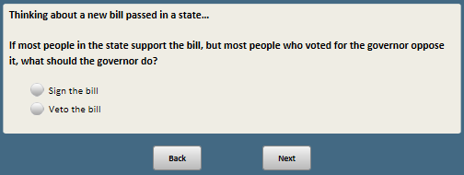

Base: xform=4 (ASK FORM 4)

*Scripter: Randomize and record response order*

**GOVVOTEGENREV [S]**

Thinking about a new bill passed in a state…

If most people in the state oppose the bill, but most people who voted for the governor support it, what should the governor do?

1. Sign the bill
2. Veto the bill

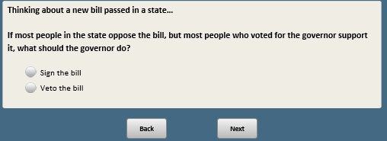

Base: xform=2 or 4 (ASK FORMS 2 and 4)

*Scripter: Randomize and record response order*

**POLCRCT [S]**

Which comes closer to your own views – even if neither is exactly right?

1 People need to be more careful about the language they use to avoid offending people with different backgrounds

2 Too many people are easily offended these days over the language that others use

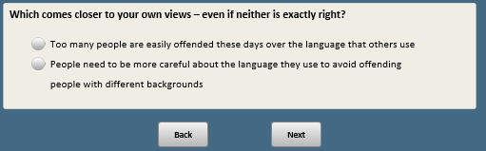

Base: xform=1 or 3 (ASK FORMS 1 and 3)

*Scripter: Randomize and record response order*

**POLRULES [S]**

Which comes closer to your view?

1 In politics, it’s sometimes necessary to bend the rules in order to get things done

2 In politics, it’s important to respect the rules, even if it sometimes makes it harder to get things done

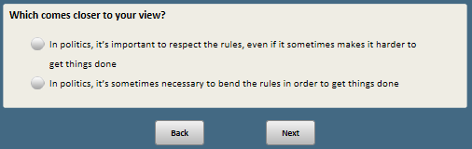

Base: ASK ALL

*Scripter: Randomize and record response order*

**CITIZ_INFL [S]**

Which statement comes closer to your views, even if neither is exactly right?

1 Ordinary citizens can do a lot to influence the government in Washington if they are willing to make the effort

2 There’s not much ordinary citizens can do to influence the government in Washington

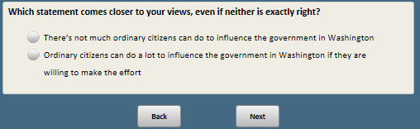

Base: ASK ALL

*Scripter: Randomize and record response order*

**VOTING [S]**

Which statement comes closer to your views, even if neither is exactly right?

1 Voting gives people like me some say about how government runs things

2 Voting by people like me doesn’t really affect how government runs things

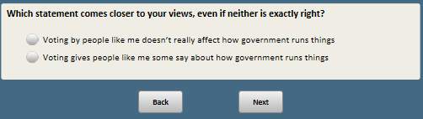

Base: ASK ALL

***Scripter: Split IMPTUS2 into two screens, with random order***

***Scripter: Randomize and record items j-q***

**IMPTUS2 [S]**

Now thinking again about the importance of a number of things for the United States.

For each of the following, HOW IMPORTANT is it for the country that…

j. The rights and freedoms of all people are respected

1 Very important

2 Somewhat important

3 Not too important

4 Not at all important

k. Everyone has an equal opportunity to succeed

1 Very important

2 Somewhat important

3 Not too important

4 Not at all important

l. The views of people who are not in the majority on issues are respected

1 Very important

2 Somewhat important

3 Not too important

4 Not at all important

m. The military leadership does not publicly express support for one party over the other

1 Very important

2 Somewhat important

3 Not too important

4 Not at all important

n. People are free to peacefully protest

1 Very important

2 Somewhat important

3 Not too important

4 Not at all important

o. News organizations don’t favor one political party

1 Very important

2 Somewhat important

3 Not too important

4 Not at all important

p. People agree on basic facts even if they disagree politically

1 Very important

2 Somewhat important

3 Not too important

4 Not at all important

q. News organizations are independent of government influence

1 Very important

2 Somewhat important

3 Not too important

4 Not at all important

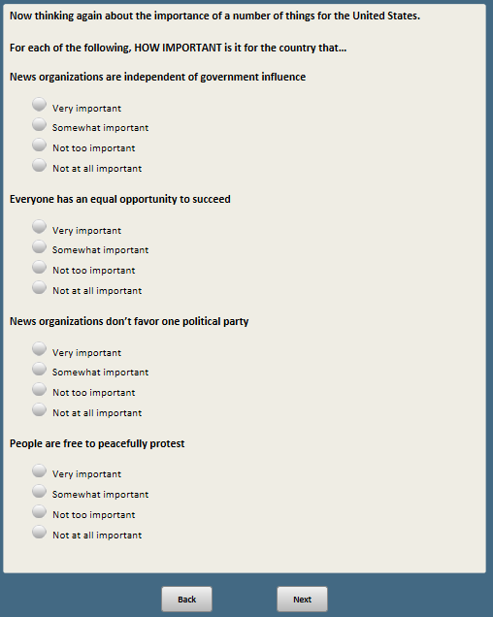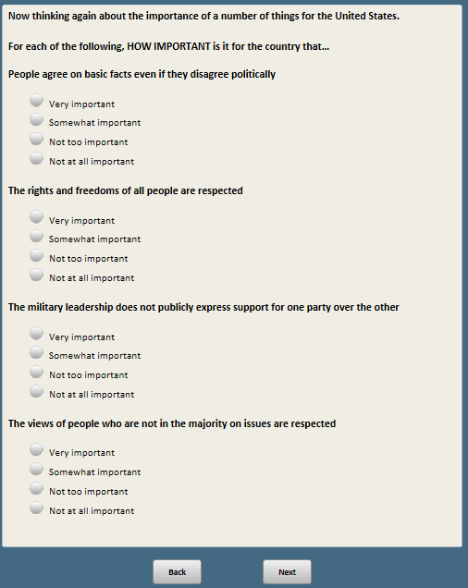 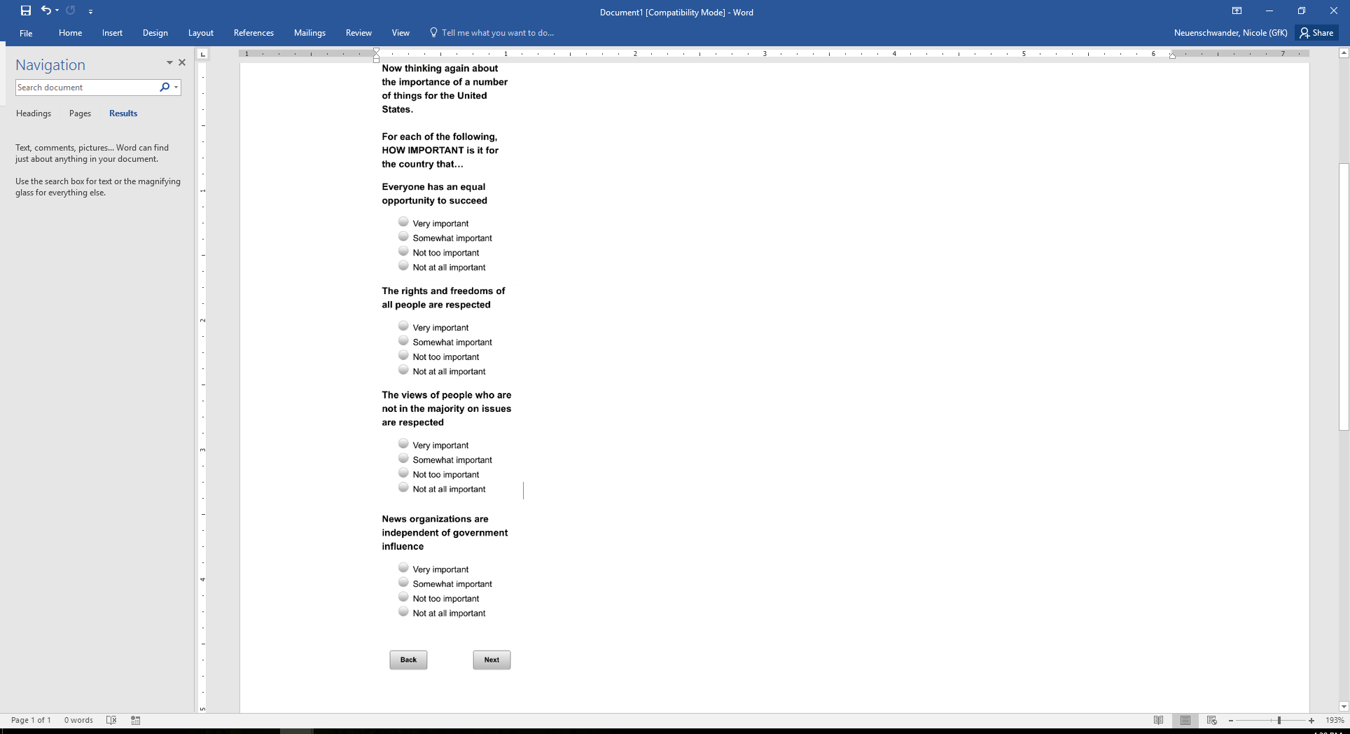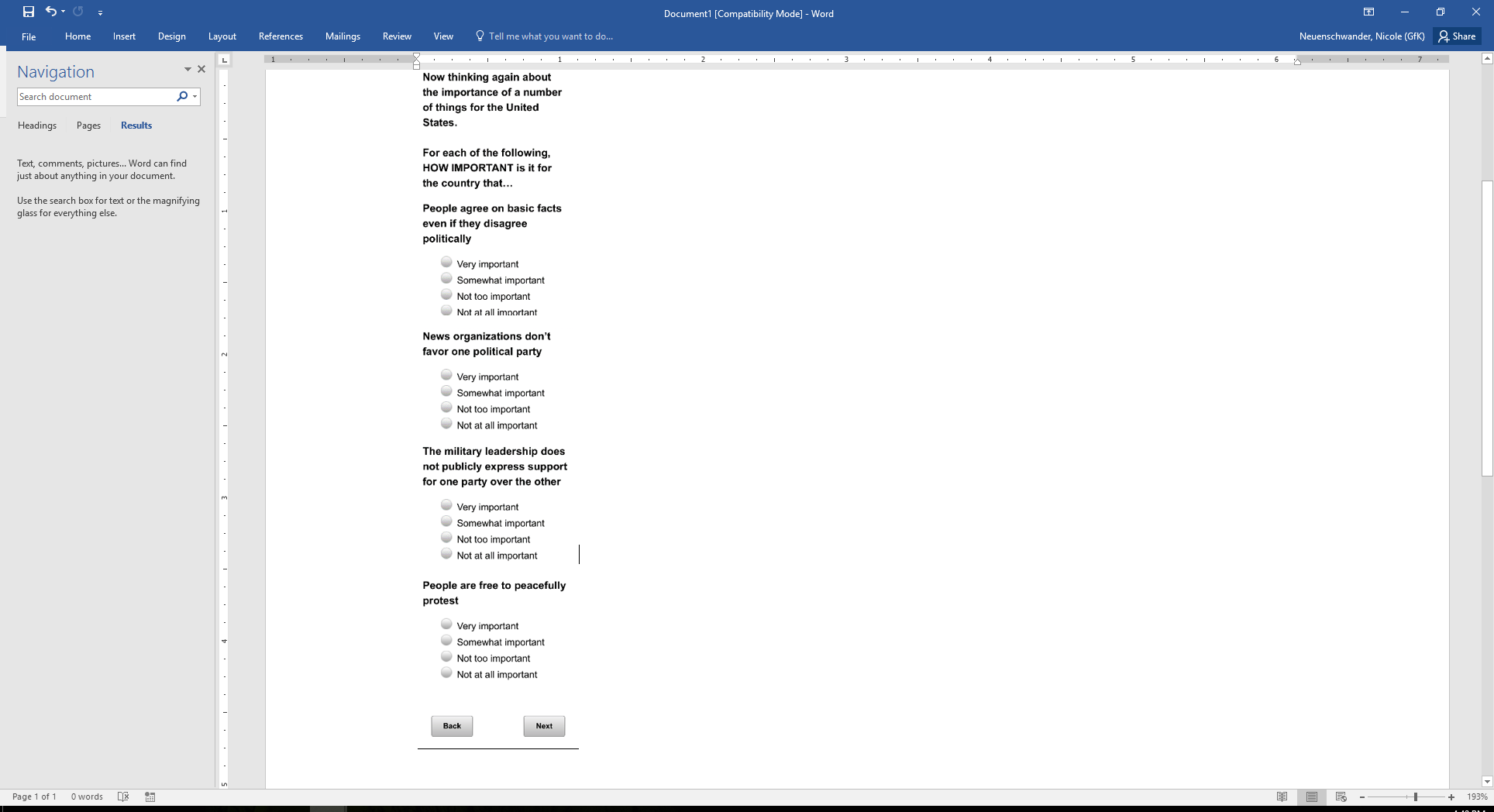

Base: ASK ALL

*Scripter: Split into two screens*

*Scripter: show in same order as IMPTUS2*

**WELLUS2 [S]**

Now thinking about how things actually are in the U.S. today…

HOW WELL does each of the following describe the country?

j. The rights and freedoms of all people are respected

1 Very well

2 Somewhat well

3 Not too well

4 Not at all well

k. Everyone has an equal opportunity to succeed

1 Very well

2 Somewhat well

3 Not too well

4 Not at all well

l. The views of people who are not in the majority on issues are respected

1 Very well

2 Somewhat well

3 Not too well

4 Not at all well

m. The military leadership does not publicly express support for one party over the other

1 Very well

2 Somewhat well

3 Not too well

4 Not at all well

n. People are free to peacefully protest

1 Very well

2 Somewhat well

3 Not too well

4 Not at all well

o. News organizations don’t favor one political party

1 Very well

2 Somewhat well

3 Not too well

4 Not at all well

p. People agree on basic facts even if they disagree politically

1 Very well

2 Somewhat well

3 Not too well

4 Not at all well

q. News organizations are independent of government influence

1 Very well

2 Somewhat well

3 Not too well

4 Not at all well

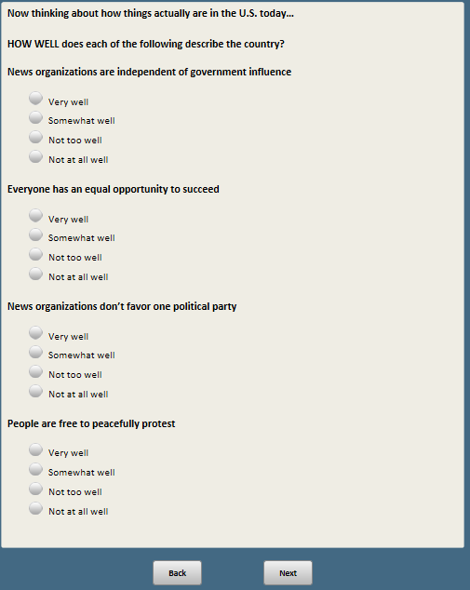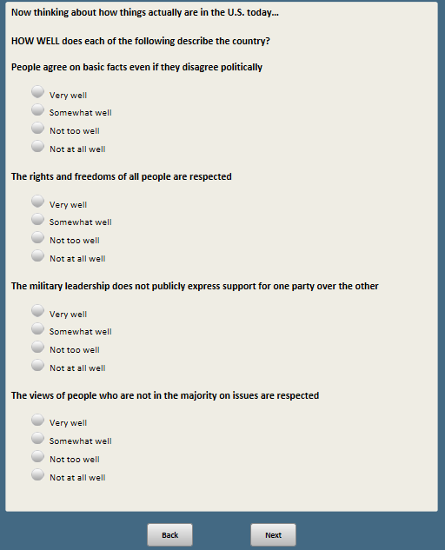

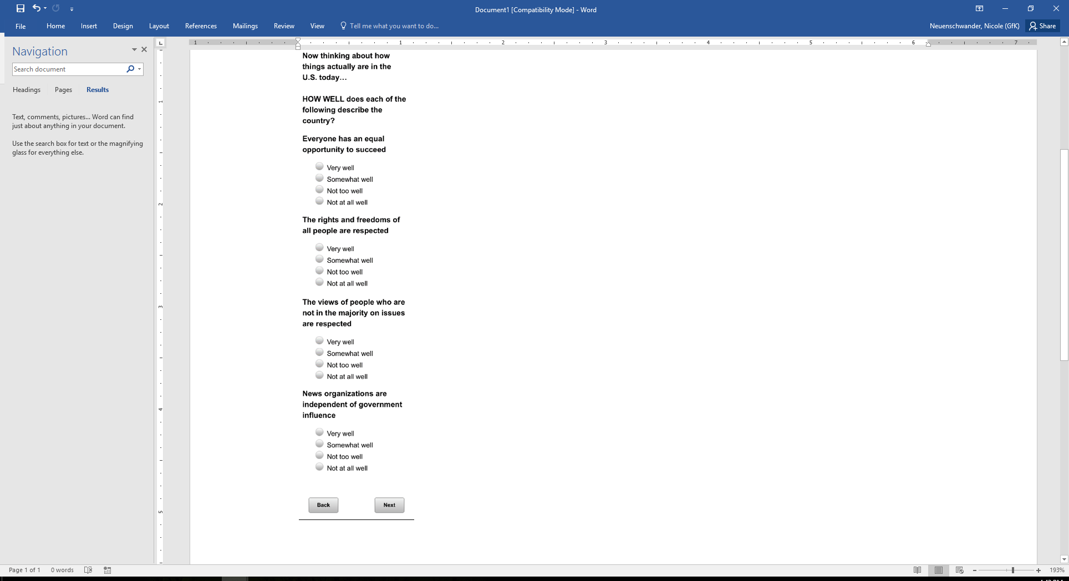 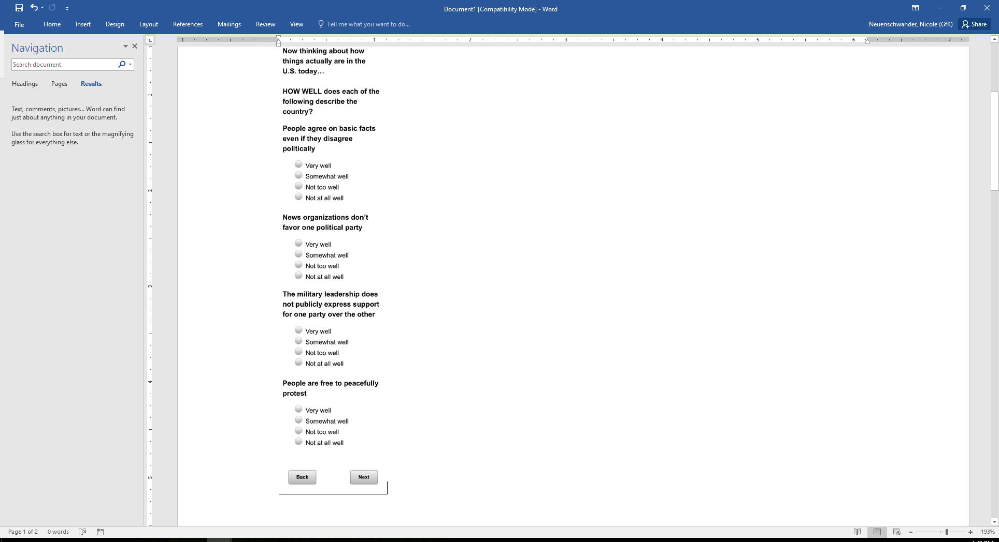

Base: ASK ALL

*Scripter: Randomize and record response order*

**DISTRESULT [S]**

Thinking about elections for U.S. House of Representatives in the district where you live. What is your impression?

1 They are usually close contests

2 One candidate usually wins easily

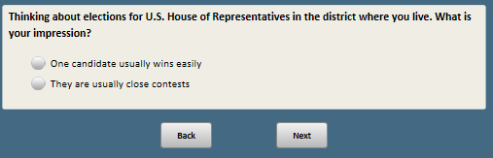

Base: ASK ALL

**CNTCT_RE [S]**

Suppose you contacted your member of the U.S. House of Representatives with a problem. How likely do you think it is that they would help you address it?

1 Very likely

2 Somewhat likely

3 Not very likely

4 Not likely at all

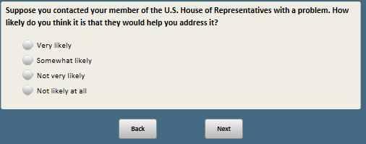

Base: xform=1 or 2 (ASK FORMS 1 and 2)

*Scripter: Randomize response options 1 and 2, record order*

**HOUSESZ [S]**

**[xform=1:** As you may know, when the first Congress met, there were 65 members, each of whom represented an average of about 60,000 people. Currently**] [xform=2:** As you may know,**]** there are 435 members of the House of Representatives in Washington, each of whom represents an average of more than 700,000 people.

Do you think the number of members in the House of Representatives should be…

1. Increased
2. Decreased
3. Stay the same

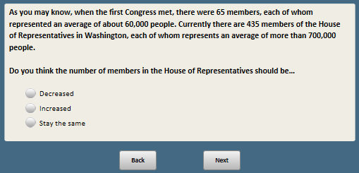

Base: xform=3 or 4 (ASK FORMS 3 and 4)

*Scripter: Randomize and record response options*

**SENATESZ [S]**

As you may know, the Constitution requires that all states have two U.S. senators, regardless of how many people live in the state. **[xform=3:** When the first Congress met, the state with the largest population had about 10 times as many people as the state with the smallest population. Currently, the state with the largest population has about 66 times as many people as the state with the smallest population.**]**

Which comes closer to your view?

1 The Constitution should not be changed, and all states should continue to have two senators regardless of the size of their population

2 The Constitution should be amended so that states with larger populations have more senators than smaller states

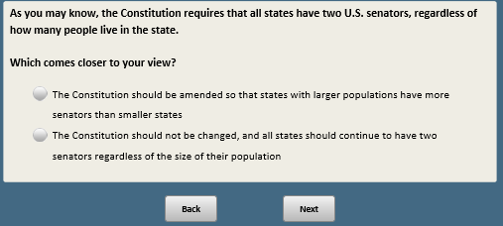

Base: xform=2 or 4 (ASK FORMS 2 and 4)

*Scripter: Randomize ELECTIMPTa-g and record.*

*Scripter: Show ELECTIMPTa-g on the same screen.*

**ELECTIMPT [S]**

Thinking about elections in the United States, HOW IMPORTANT is each of the following?

a Elections are free from tampering

1 Very important

2 Somewhat important

3 Not too important

4 Not at all important

b. No INELIGIBLE voters are permitted to vote

1 Very important

2 Somewhat important

3 Not too important

4 Not at all important

c. No ELIGIBLE voters are prevented from voting

1 Very important

2 Somewhat important

3 Not too important

4 Not at all important

d. The way congressional voting districts are determined is fair and reasonable

1 Very important

2 Somewhat important

3 Not too important

4 Not at all important

e. Voters are knowledgeable about candidates and issues

1 Very important

2 Somewhat important

3 Not too important

4 Not at all important

f.F2 **[if xform=2]**There is high voter turnout in presidential elections

1 Very important

2 Somewhat important

3 Not too important

4 Not at all important

g.F4 **[if xform=4]**There is high voter turnout in local elections

1 Very important

2 Somewhat important

3 Not too important

4 Not at all important

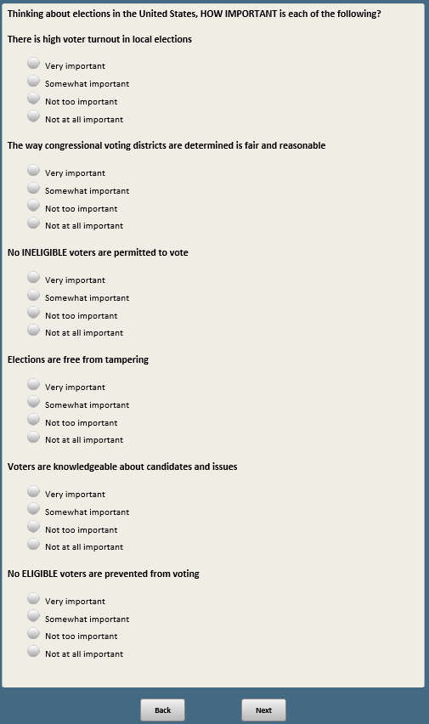

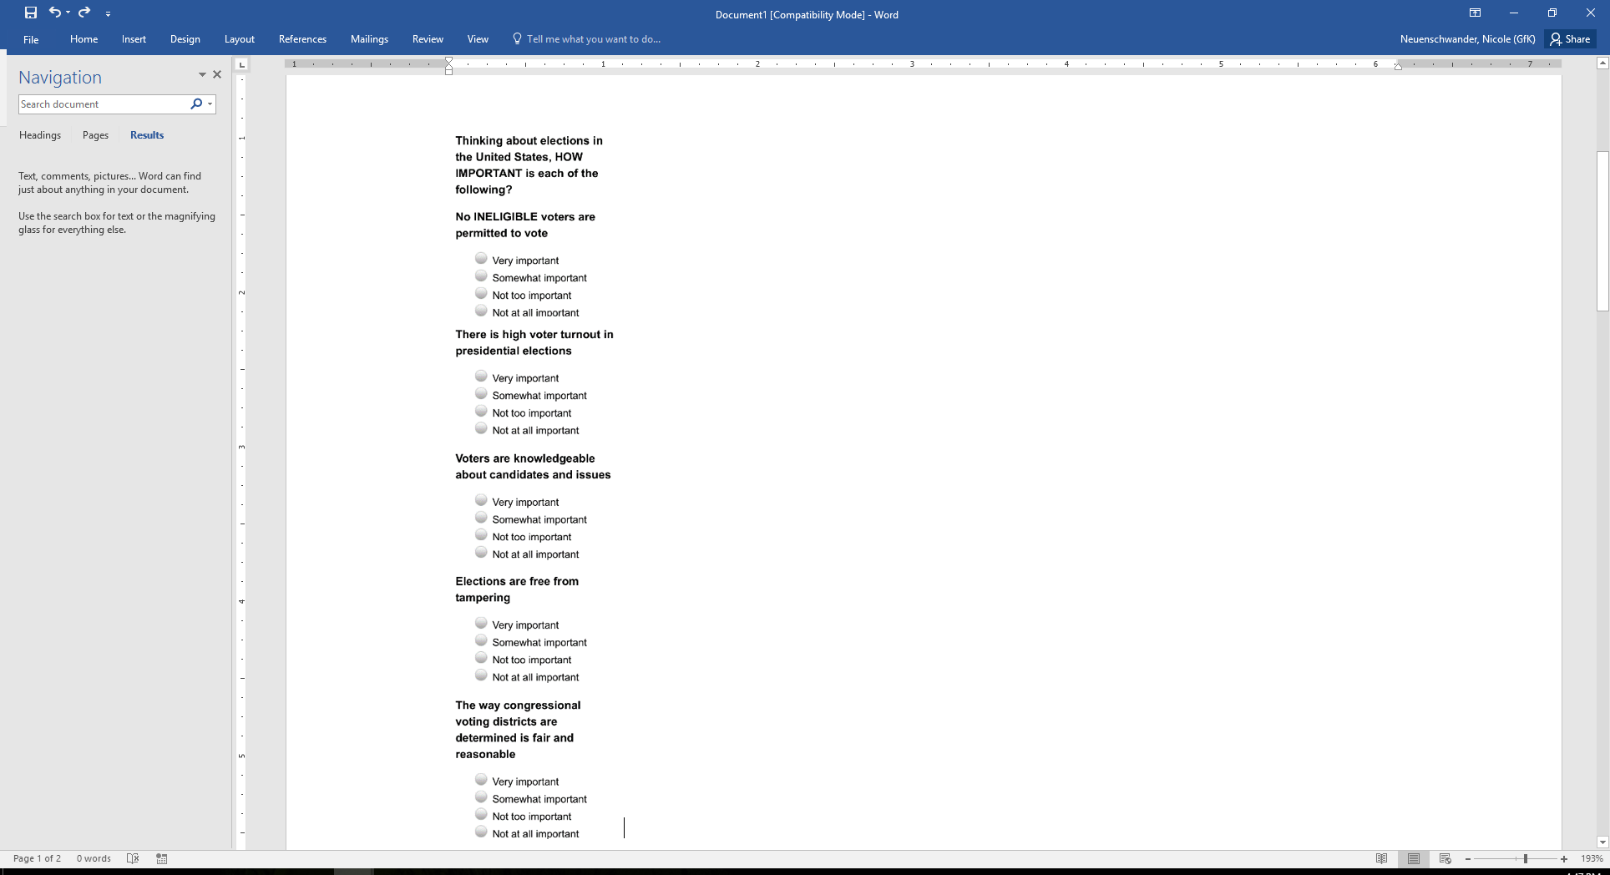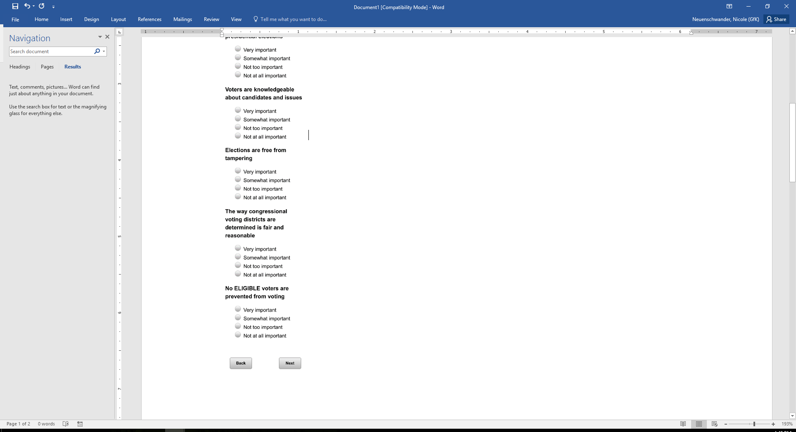

Base: xform=2 or 4 (ASK ALL FORMS 2 and 4)

*Scripter: Show ELECTWELLa-g in same order as ELECTIMPa-g*

*Scripter: Show ELECTWELLa-g on the same screen.*

**ELECTWELL [S]**

Next still thinking about elections, HOW WELL does each of the following describe elections in the United States?

a Elections are free from tampering

1 Very well

2 Somewhat well

3 Not too well

4 Not at all well

b. No INELIGIBLE voters are permitted to vote

1 Very well

2 Somewhat well

3 Not too well

4 Not at all well

c. No ELIGIBLE voters are prevented from voting

1 Very well

2 Somewhat well

3 Not too well

4 Not at all well

d. The way congressional voting districts are determined is fair and reasonable

1 Very well

2 Somewhat well

3 Not too well

4 Not at all well

e. Voters are knowledgeable about candidates and issues

1 Very well

2 Somewhat well

3 Not too well

4 Not at all well

f.FA **[if xform=2]**There is high voter turnout in presidential elections

1 Very well

2 Somewhat well

3 Not too well

4 Not at all well

g.FB **[if xform=4]**There is high voter turnout in local elections

1 Very well

2 Somewhat well

3 Not too well

4 Not at all well

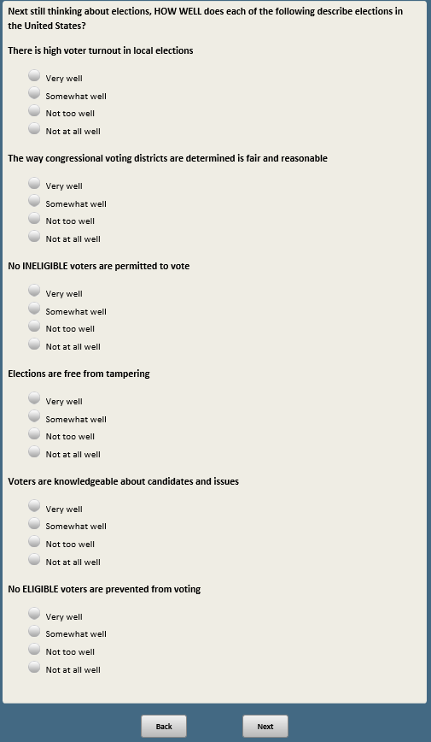

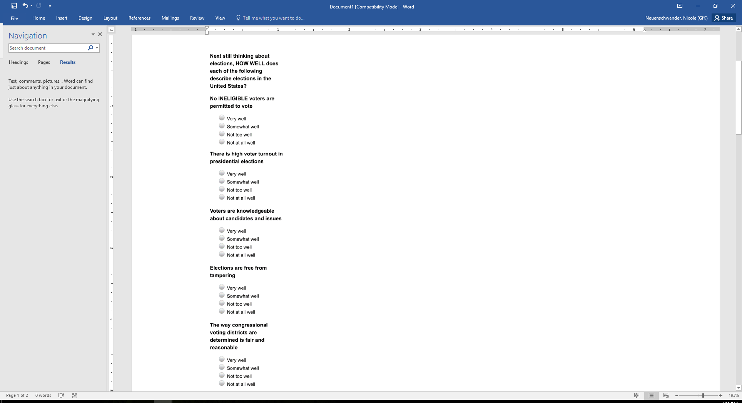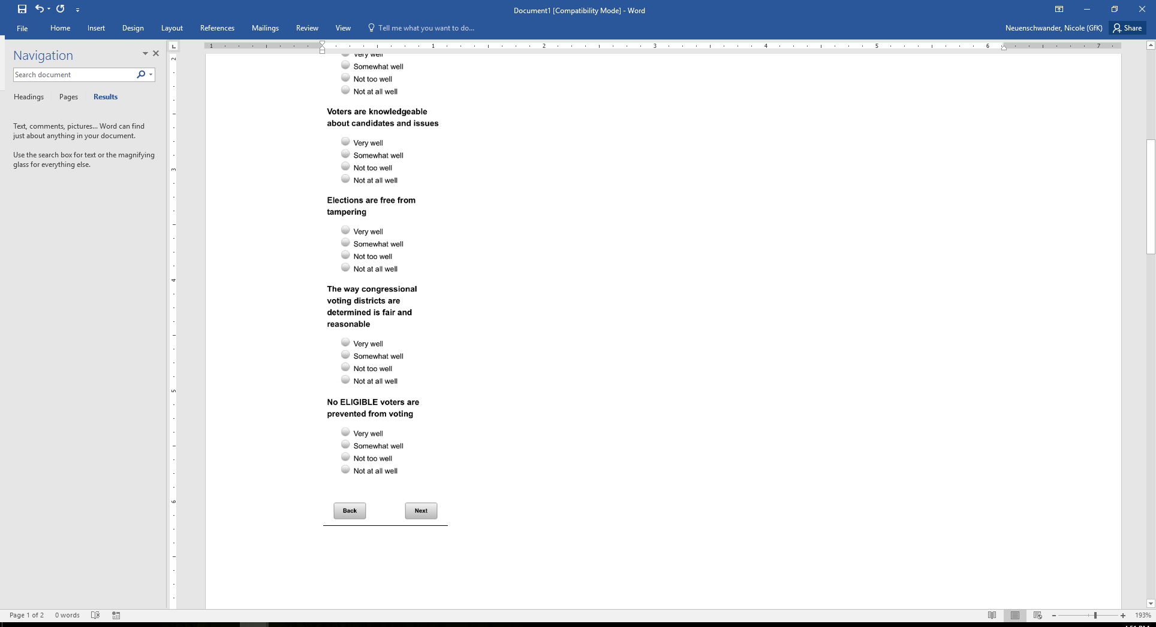

Base: xform=1 or 3 (ASK FORMS 1 and 3)

**WINLOSE [S]**

Thinking about the way things have been going in politics over the last few years on the issues that matter to you, would you say your side has been...

1 Winning more often than losing

2 Losing more often than winning

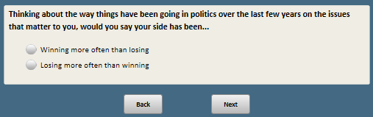

Base: xform=1 or 3 (ASK FORMS 1 and 3)

*Scripter: Show CITIZENIMPORT on two screens with random order*

*Scripter: Randomize items a-k and record order*

**CITIZENIMPORT [S]**

Thinking about what it means to be a good citizen, how important is it to…

a. Vote in elections

1 Very important

2 Somewhat important

3 Not too important

4 Not at all important

b. Follow what is happening in government and politics

1 Very important

2 Somewhat important

3 Not too important

4 Not at all important

c. Volunteer to help others

1 Very important

2 Somewhat important

3 Not too important

4 Not at all important

d. Serve jury duty if called

1 Very important

2 Somewhat important

3 Not too important

4 Not at all important

e. Participate in the U.S. Census every 10 years

1 Very important

2 Somewhat important

3 Not too important

4 Not at all important

f. Pay all the taxes you owe

1 Very important

2 Somewhat important

3 Not too important

4 Not at all important

g. Always follow the law

1 Very important

2 Somewhat important

3 Not too important

4 Not at all important

h.F1 **[if xform=1]**Display the American flag

1 Very important

2 Somewhat important

3 Not too important

4 Not at all important

i.F3. **[if xform=3]**Know the Pledge of Allegiance

1 Very important

2 Somewhat important

3 Not too important

4 Not at all important

j. Respect the opinions and beliefs of those you disagree with

1 Very important

2 Somewhat important

3 Not too important

4 Not at all important

k. Protest if you think government actions are wrong

1 Very important

2 Somewhat important

3 Not too important

4 Not at all important

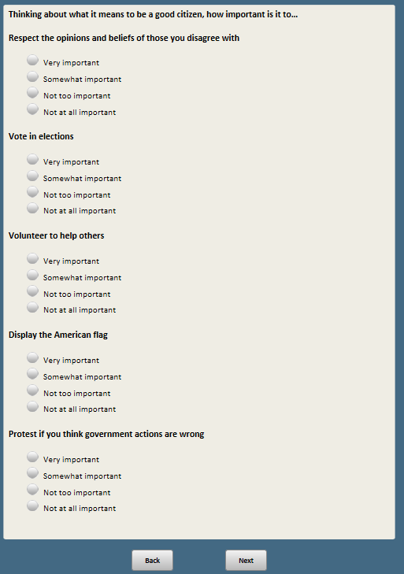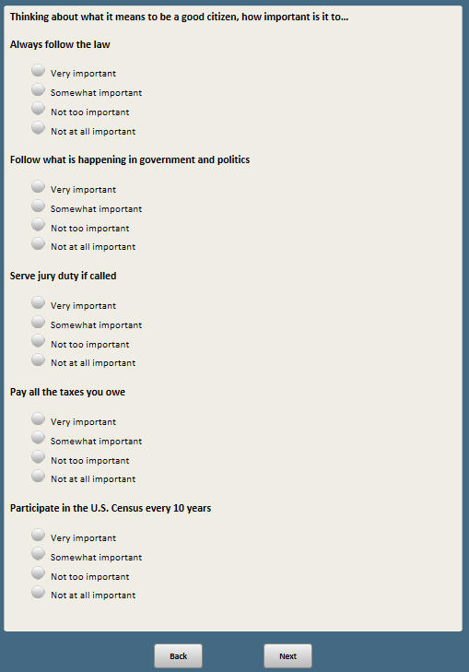

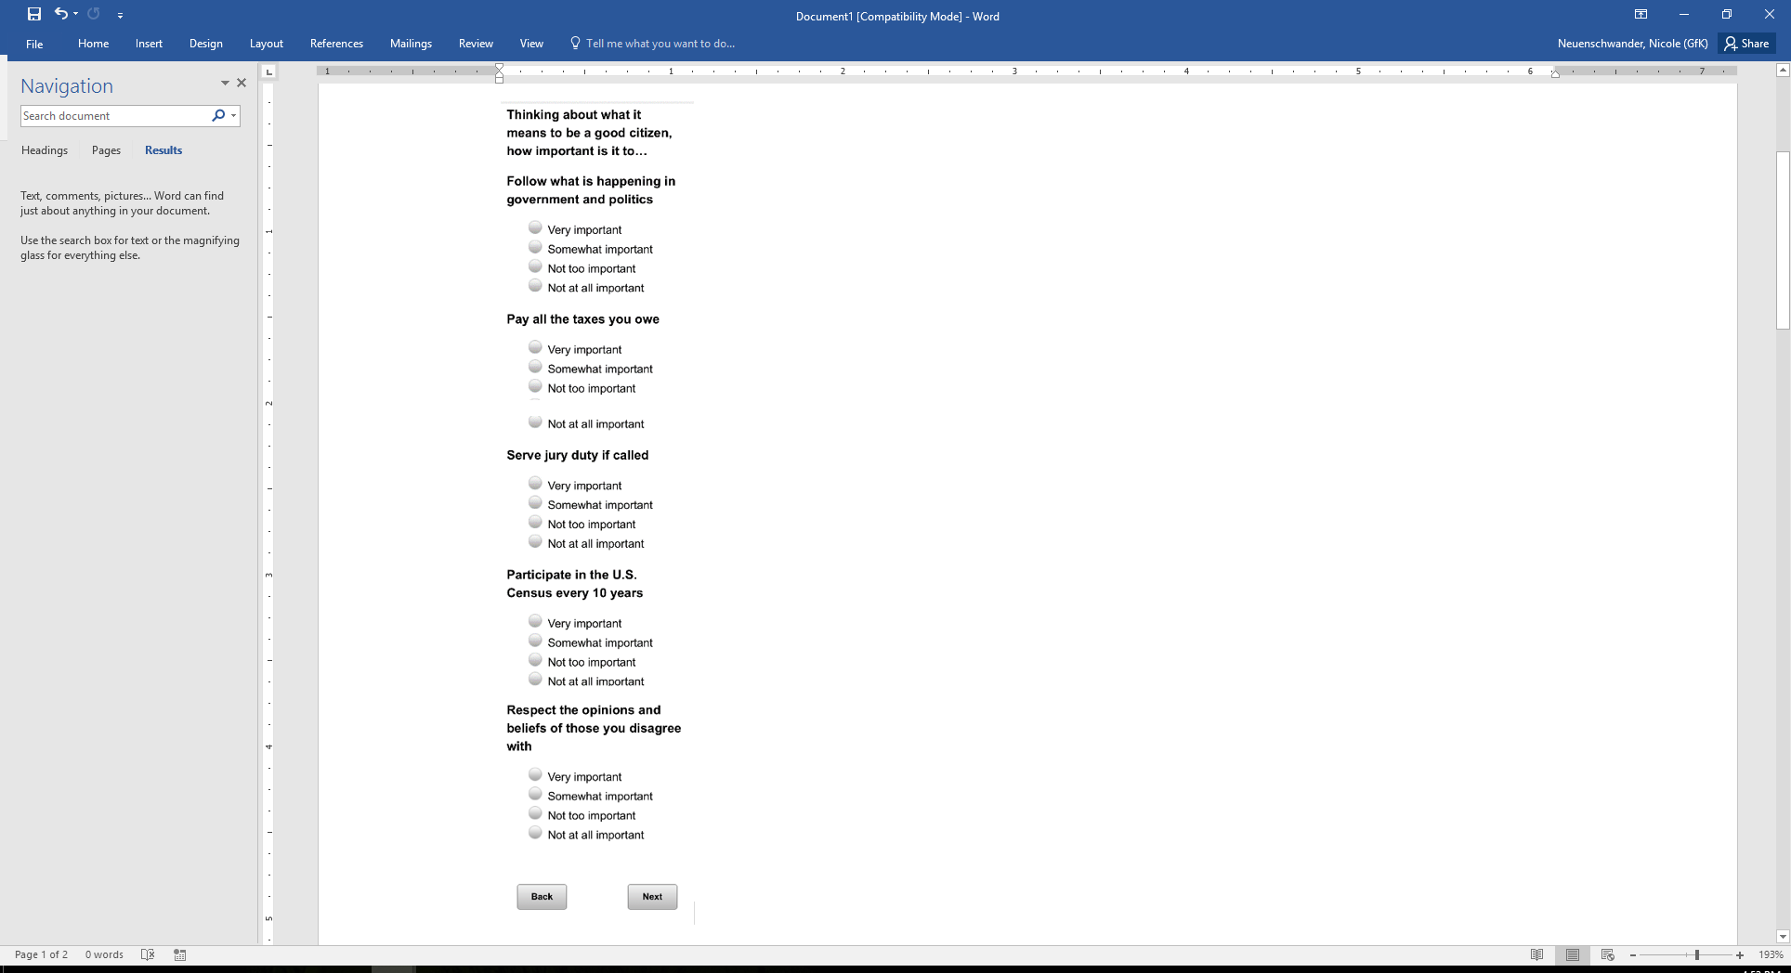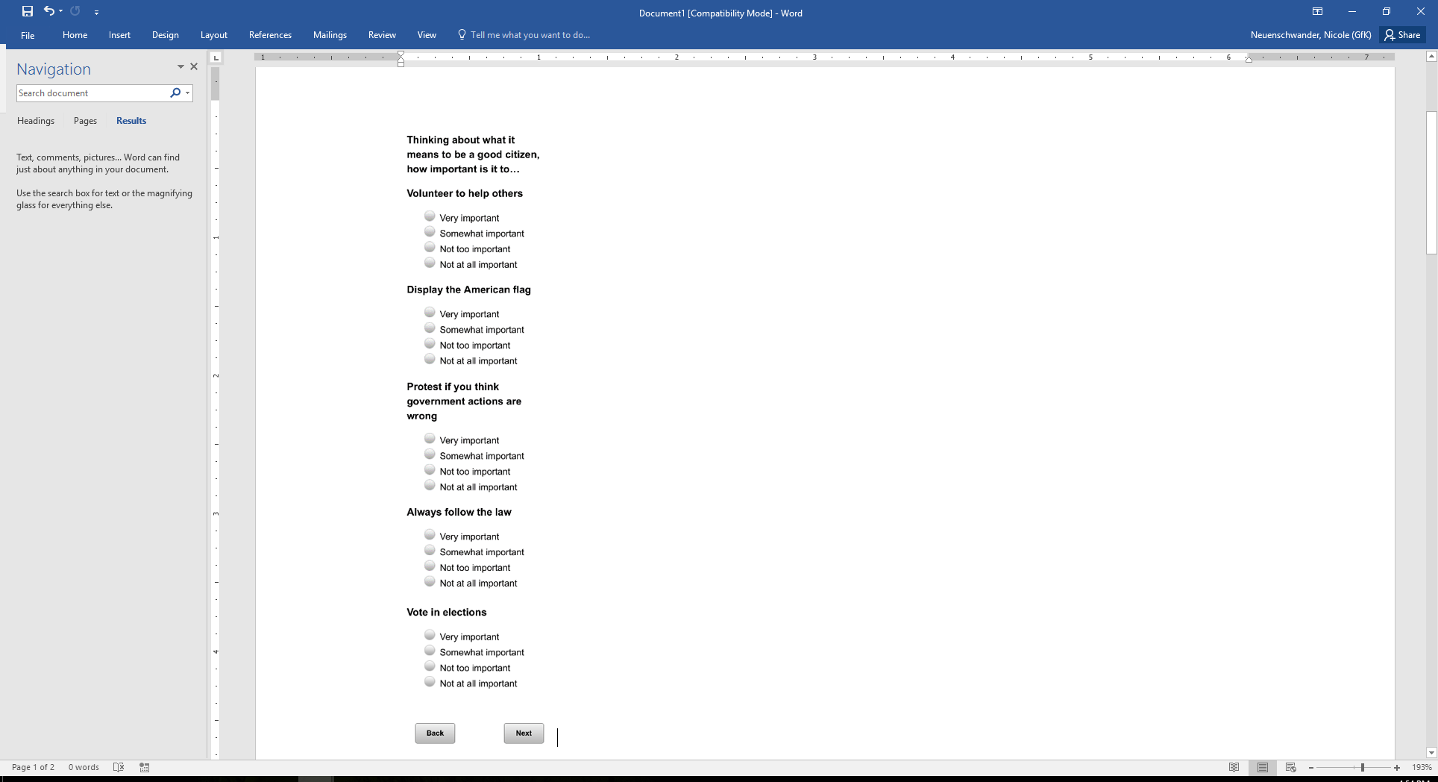

Base: xform=1 (ASK IF FORM 1)

**CANQUALPRES [S]**

In general, would you say the quality of the candidates running for president in the last several elections has been…

1 Very good

2 Somewhat good

3 Somewhat bad

4 Very bad

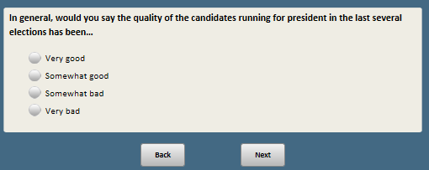

Base: xform=2 (ASK IF FORM 2)

**CANQUALLCL [S]**

In general, would you say the quality of the candidates running in local elections (such as for mayor or county government) in the last several elections in your area has been…

1 Very good

2 Somewhat good

3 Somewhat bad

4 Very bad

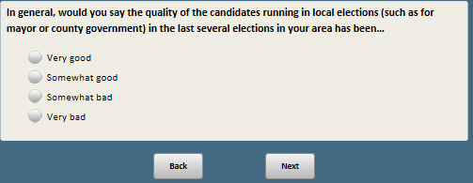

Base: xform=3 (ASK IF FORM 3)

**CANQUALCONG [S]**

In general, would you say the quality of the candidates running for Congress in the last several elections in your district has been…

1 Very good

2 Somewhat good

3 Somewhat bad

4 Very bad

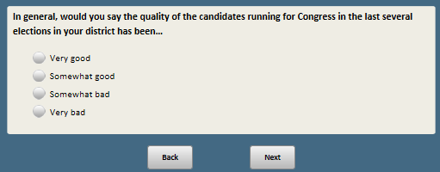

Base: xform=4 (ASK IF FORM 4)

**CANQUALPOL [S]**

In general, would you say the quality of the candidates running for political office in the last several years has been…

1 Very good

2 Somewhat good

3 Somewhat bad

4 Very bad

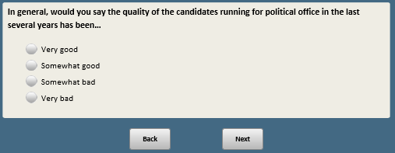

Base: xform=1 (ASK FORM 1)

*Scripter: Randomize and record response order*

**CANMTCHPRES [S]**

Which comes closer to your view of candidates for presidential elections, even if neither is exactly right?

1 I usually feel like there is at least one candidate who shares most of my views

2 I usually feel like none of the candidates represent my views well

### 

Base: xform=2 (ASK FORM 2)

*Scripter: Randomize and record response order*

**CANMTCHLCL [S]**

Which comes closer to your view of candidates for local elections for positions like mayor or county government, even if neither is exactly right?

1 I usually feel like there is at least one candidate who shares most of my views

2 I usually feel like none of the candidates represent my views well

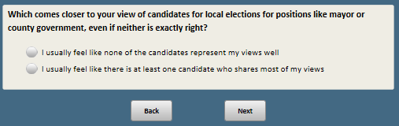

Base: xform=3 (ASK FORM 3)

*Scripter: Randomize and record response order*

**CANMTCHCONG [S]**

Which comes closer to your view of candidates for congressional elections, even if neither is exactly right?

1 I usually feel like there is at least one candidate who shares most of my views

2 I usually feel like none of the candidates represent my views well

### 

Base: xform=4 (ASK FORM 4)

*Scripter: Randomize and record response order*

**CANMTCHPOL [S]**

Which comes closer to your view of candidates for political office, even if neither is exactly right?

1 I usually feel like there is at least one candidate who shares most of my views

2 I usually feel like none of the candidates represent my views well

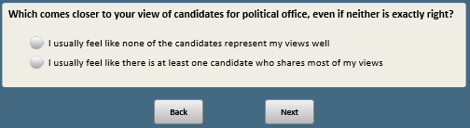

Base: ASK ALL

*Scripter: Show CIVIC_ENG_ACTa-k on the same screen.*

*Scripter: Randomize items a-k and record order*

*Note: no items b, d, e, f, or i*

**CIVIC_ENG_ACT [S]**

Here’s a list of activities some people do and others do not. Please indicate if you have done each of the following activities.

a. Attended a political rally, speech or campaign event

1 Yes, in the past year

2 Yes, in the last 5 years, but not in the past year

3 No

c. Worked or volunteered for a political party, candidate or campaign

1 Yes, in the past year

2 Yes, in the last 5 years, but not in the past year

3 No

g. Contacted any elected official

1 Yes, in the past year

2 Yes, in the last 5 years, but not in the past year

3 No

h. Contributed money to a candidate running for public office or to a group working to elect a candidate

1 Yes, in the past year

2 Yes, in the last 5 years, but not in the past year

3 No

j. Publicly expressed your support for a political campaign on Facebook, Twitter or other social media

1 Yes, in the past year

2 Yes, in the last 5 years, but not in the past year

3 No

k. Attended government meetings in your community, such as city or town council meetings

1 Yes, in the past year

2 Yes, in the last 5 years, but not in the past year

3 No

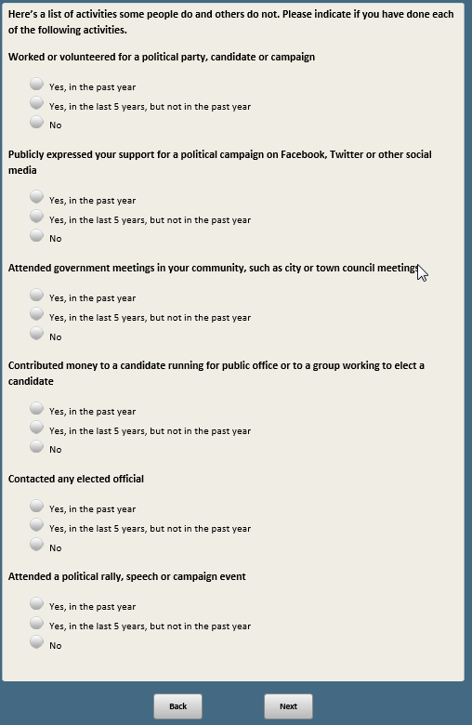

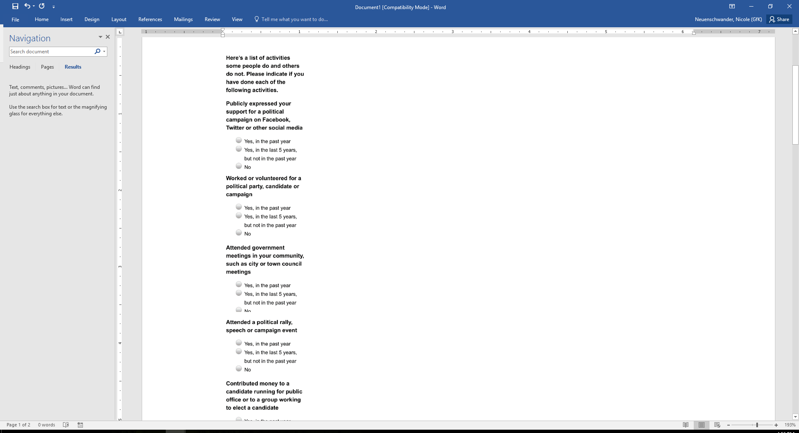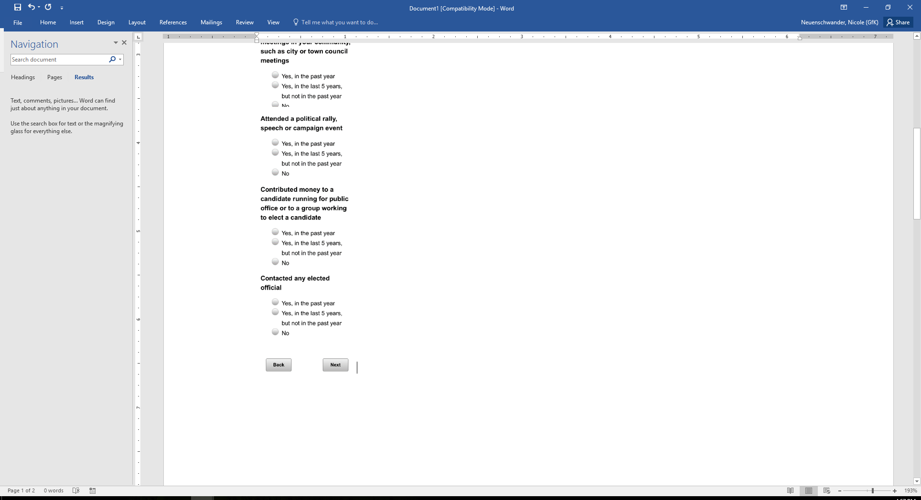

Base: CIVIC_ENG_ACT_h=1 (ASK CONTRIBUTORS)

**CONTRHOWMUCH [S]**

Thinking about the contributions you have made to a candidate running for public office or to a group working to elect a candidate in the past year, would you say all of those contributions added up to…

1 Less than $100

2 $100 to less than $250

3 More than $250

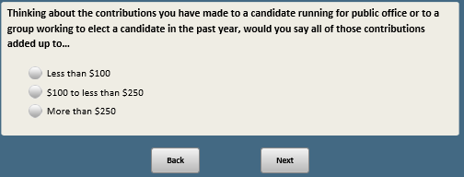

Base: xform=1 or 4 (ASK FORM 1 & 4)

**SHAREVIEWS [S]**

Which of the following statements best describes you?

1 Most of my close friends share my views on government and politics

2 Some of my close friends share my views, but many do not

3 I don’t really know what most of my close friends think about government and politics

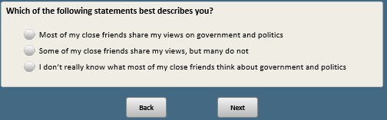

Base: (xform=2 or 3) and xdigital=1 (gets news digitally)

ATP ONLY

*Scripter: Randomize and record options 1 and 2*

**DIGWDOG_3 [S]**

Thinking about the news that your friends, family and acquaintances post or send you online about political and social issues, overall, do you think the mix of news you get from them…

1. Represents just one side
2. Represents more than one side

**[SPACE]**

1. They don’t send me news about political and social issues

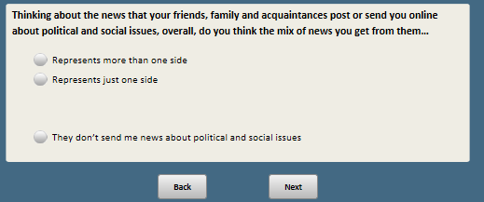

Base: ASK ALL

**PLANTOP [S]**

As you may know, primary elections, where parties select their nominees, take place in the months before general elections. How likely are you to vote in the primary elections for Congress this year?

1 I definitely will vote in the primary elections

2 I probably will vote

3 I probably will not vote

4 I definitely will not vote

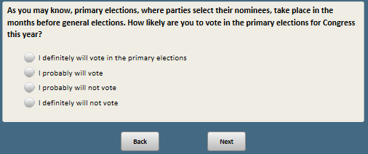

Base: ASK ALL

**PARTY [S]**

In politics today, do you consider yourself a:

1 Republican

2 Democrat

3 Independent

4 Something else

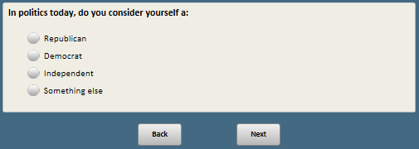

Base: PARTY=3 or 4 or 99 (ASK IF PARTY is INDEP/SOMETHING ELSE/ missing)

**PARTYLN [S]**

As of today do you lean more to…

1 The Republican Party

2 The Democratic Party

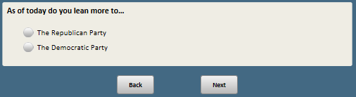

Base: PARTY=1 (ASK REPUBLICANS)

*Scripter: show IDENTITYREPa-e on the same screen*

*Scripter: randomize items a-e and record order*

**IDENTITYREP [S]**

How much of a reason is each of the following for WHY YOU ARE A REPUBLICAN?

a. I think the Republican Party’s policies are good for the country

1 Major reason

2 Minor reason

3 Not a reason

b. I think the Democratic Party’s policies are harmful to the country

1 Major reason

2 Minor reason

3 Not a reason

c. I have a lot in common with people who are Republicans

1 Major reason

2 Minor reason

3 Not a reason

d. I don’t have much in common with people who are Democrats

1 Major reason

2 Minor reason

3 Not a reason

e. Ever since I can remember, I’ve been a Republican

1 Major reason

2 Minor reason

3 Not a reason

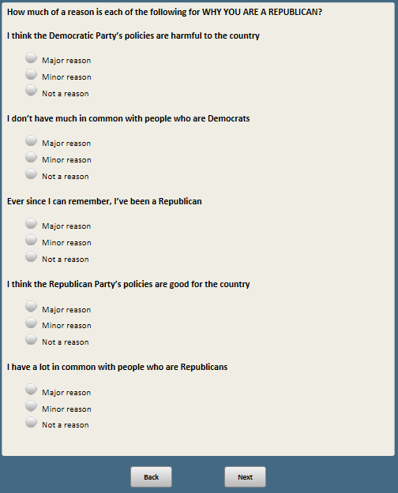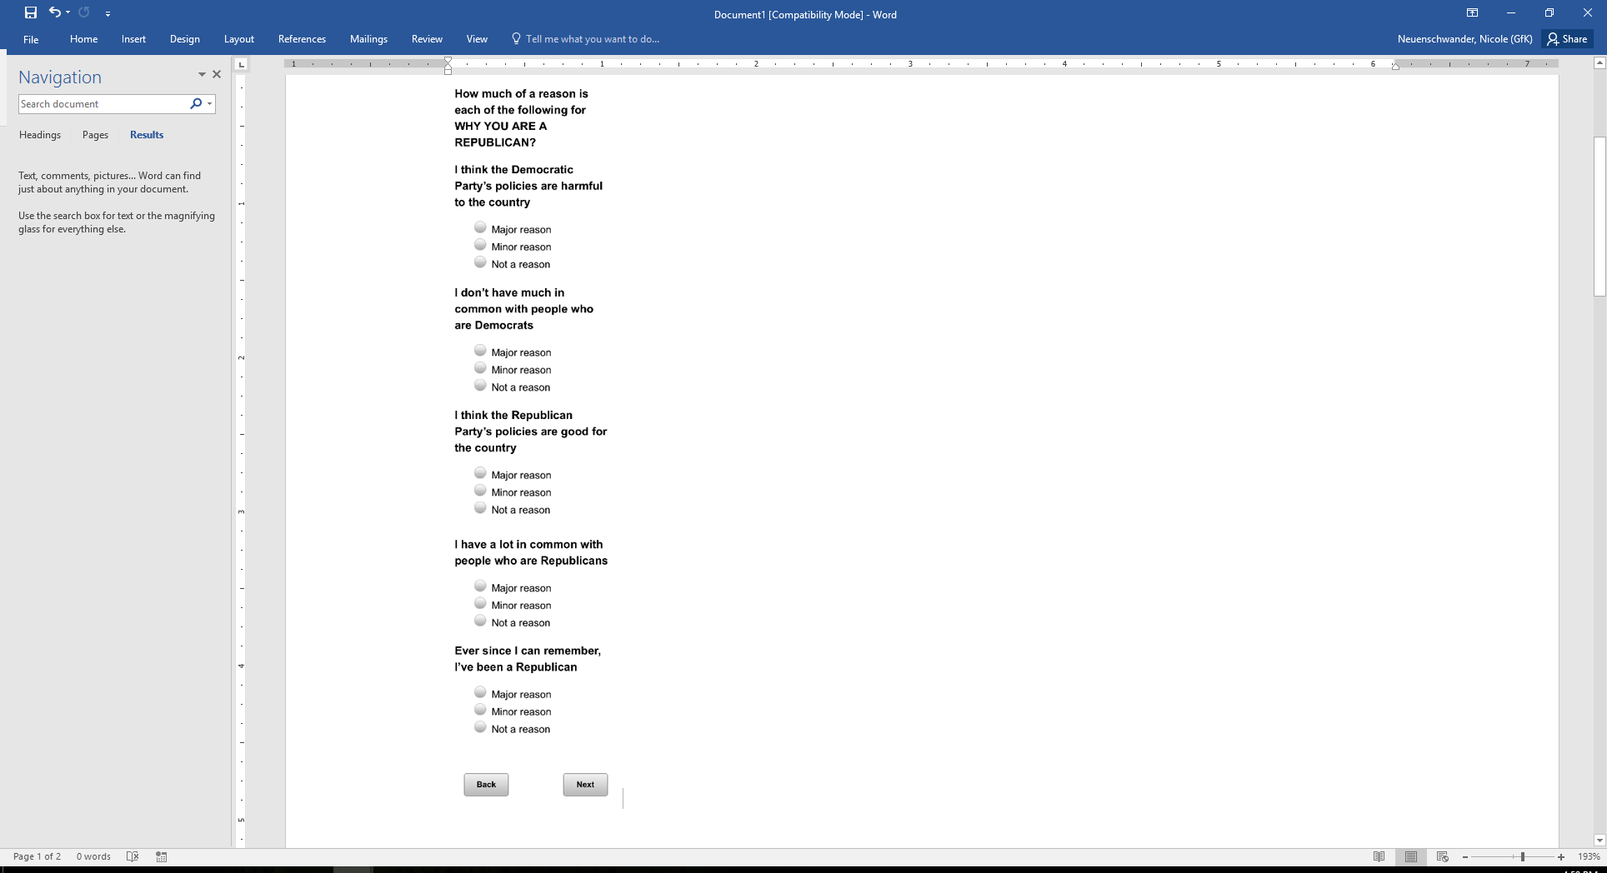

Base: PARTY=2 (ASK DEMOCRATS)

*Scripter: show IDENTITYDEPa-e on the same screen*

*Scripter: randomize items a-e and record order*

**IDENTITYDEM [S]**

How much of a reason is each of the following for WHY YOU ARE A DEMOCRAT?

a. I think the Democratic Party’s policies are good for the country

1 Major reason

2 Minor reason

3 Not a reason

b. I think the Republican Party’s policies are harmful to the country

1 Major reason

2 Minor reason

3 Not a reason

c. I have a lot in common with people who are Democrats

1 Major reason

2 Minor reason

3 Not a reason

d. I don’t have much in common with people who are Republicans

1 Major reason

2 Minor reason

3 Not a reason

e. Ever since I can remember, I’ve been a Democrat

1 Major reason

2 Minor reason

3 Not a reason

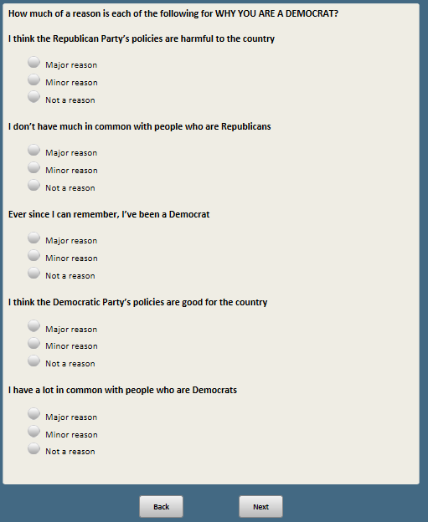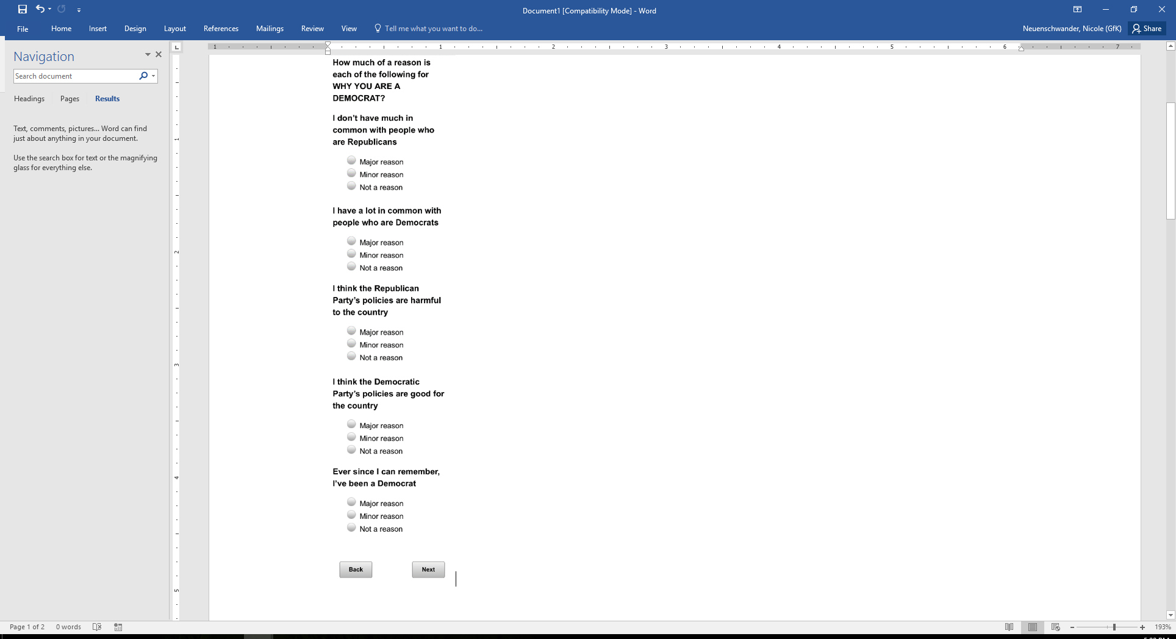

Base: PARTYLN=1 (Republican leaners)

*Scripter: show IDENTITYLN1Ra-d on the same screen*

*Scripter: randomize items a-d and record order*

**IDENTITYLN1R [S]**

How much of a reason is each of the following for WHY YOU LEAN TOWARD THE REPUBLICAN PARTY?

a. I think the Republican Party’s policies are good for the country

1 Major reason

2 Minor reason

3 Not a reason

b. I think the Democratic Party’s policies are harmful to the country

1 Major reason

2 Minor reason

3 Not a reason

c. I have a lot in common with people who are Republicans

1 Major reason

2 Minor reason

3 Not a reason

d. I don’t have much in common with people who are Democrats

1 Major reason

2 Minor reason

3 Not a reason

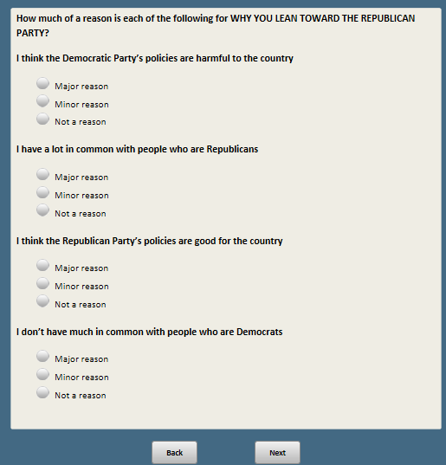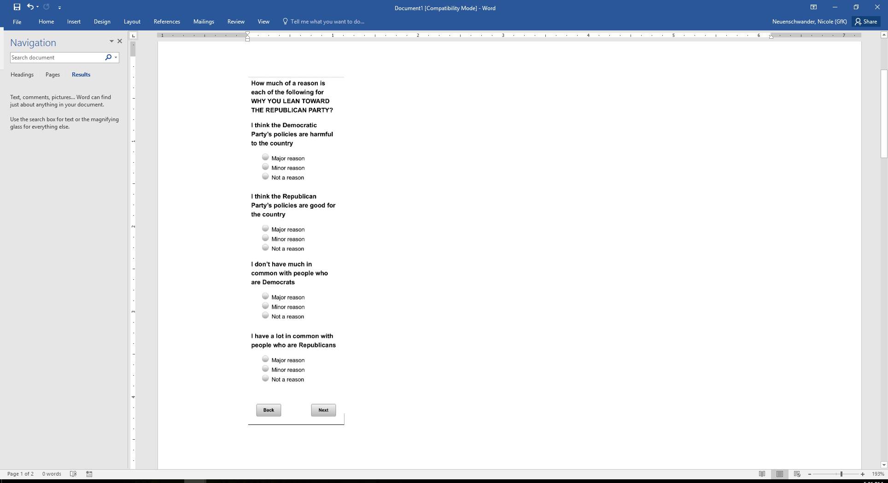

Base: PARTYLN=1 (Republican leaners)

*Scripter: show IDENTITYLN2Ra-d on the same screen*

*Scripter: randomize items a-d and record order*

**IDENTITYLN2R [S]**

And thinking about why you lean toward the Republican Party but choose not to identify as a Republican…

How much of a reason is each of the following for WHY YOU DO NOT IDENTIFY AS A REPUBLICAN?

a. I disagree with the Republican Party on some important issues

1 Major reason

2 Minor reason

3 Not a reason

b. I’m frustrated with the Republican Party’s leaders

1 Major reason

2 Minor reason

3 Not a reason

c. I don’t care enough about politics to identify with a party

1 Major reason

2 Minor reason

3 Not a reason

d. I’m just not comfortable being labeled a Republican

1 Major reason

2 Minor reason

3 Not a reason

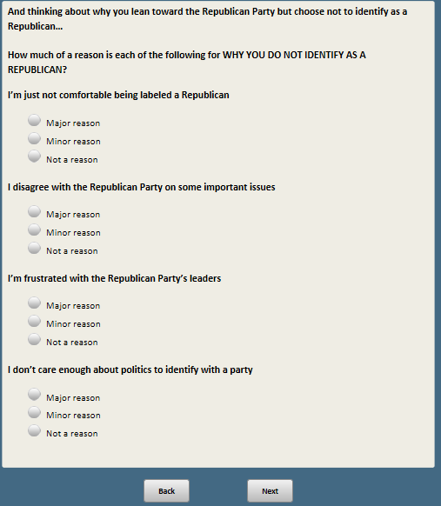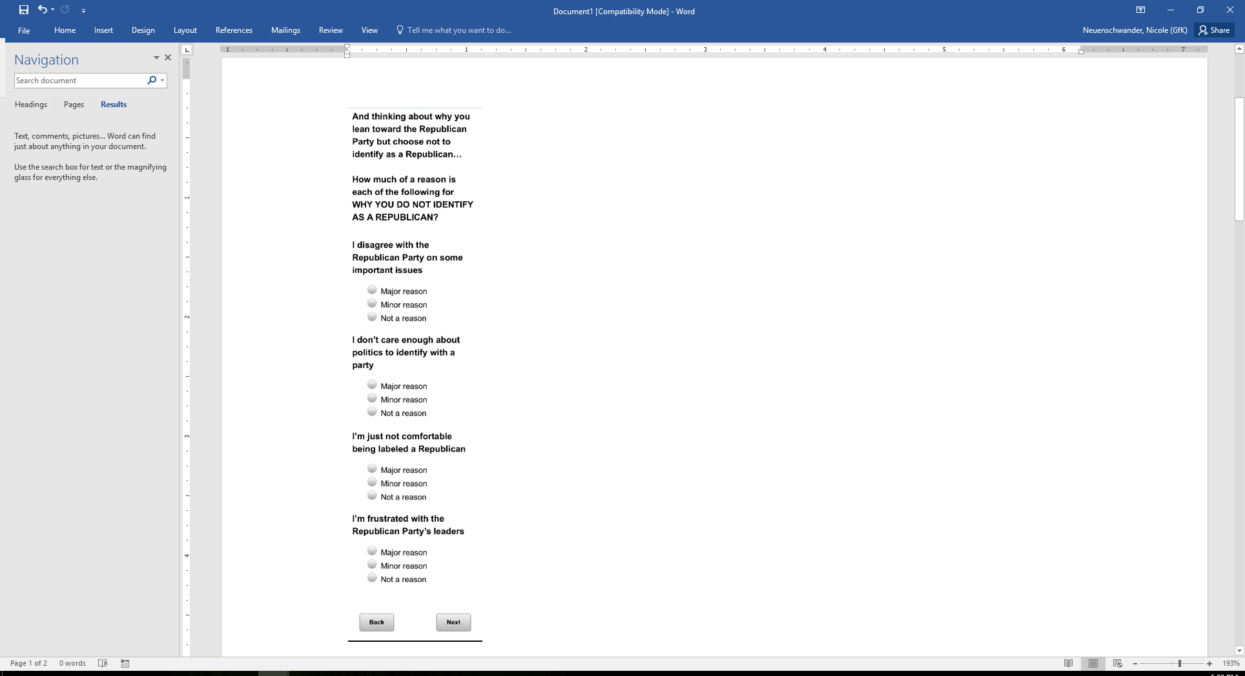

Base: PARTYLN=2 (Democrat leaners)

*Scripter: show IDENTITYLN1Da-d on the same screen*

*Scripter: randomize items a-d and record order*

**IDENTITYLN1D [S]**

How much of a reason is each of the following for WHY YOU LEAN TOWARD THE DEMOCRATIC PARTY?

a. I think the Democratic Party’s policies are good for the country

1 Major reason

2 Minor reason

3 Not a reason

b. I think the Republican Party’s policies are harmful to the country

1 Major reason

2 Minor reason

3 Not a reason

c. I have a lot in common with people who are Democrats

1 Major reason

2 Minor reason

3 Not a reason

d. I don’t have much in common with people who are Republicans

1 Major reason

2 Minor reason

3 Not a reason

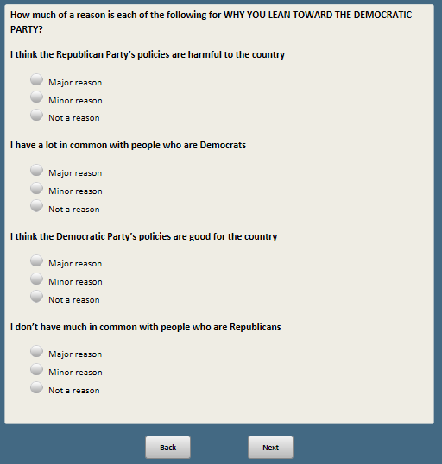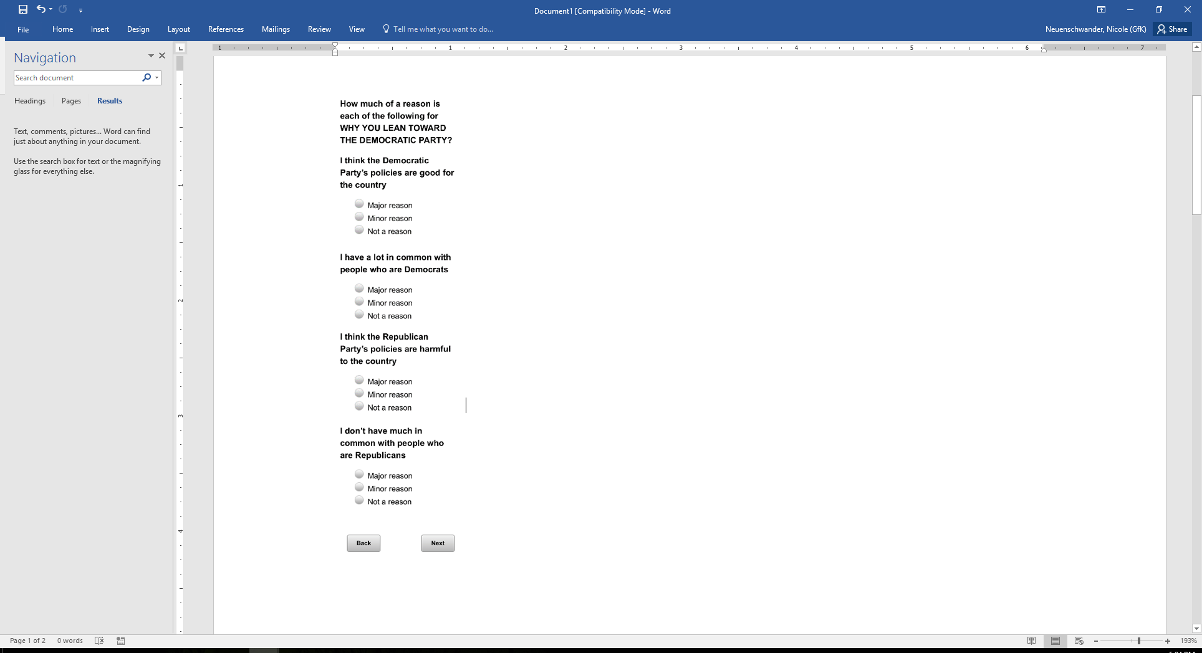

Base: PARTYLN=2 (Democrat leaners)

*Scripter: show IDENTITYLN2Da-d on the same screen*

*Scripter: randomize items a-d and record order*

**IDENTITYLN2D [S]**

And thinking about why you lean toward the Democratic Party but choose not to identify as a Democrat…

How much of a reason is each of the following for WHY YOU DO NOT IDENTIFY AS A DEMOCRAT?

a. I disagree with the Democratic Party on some important issues

1 Major reason

2 Minor reason

3 Not a reason

b. I’m frustrated with the Democratic Party’s leaders

1 Major reason

2 Minor reason

3 Not a reason

c. I don’t care enough about politics to identify with a party

1 Major reason

2 Minor reason

3 Not a reason

d. I’m just not comfortable being labeled a Democrat

1 Major reason

2 Minor reason

3 Not a reason

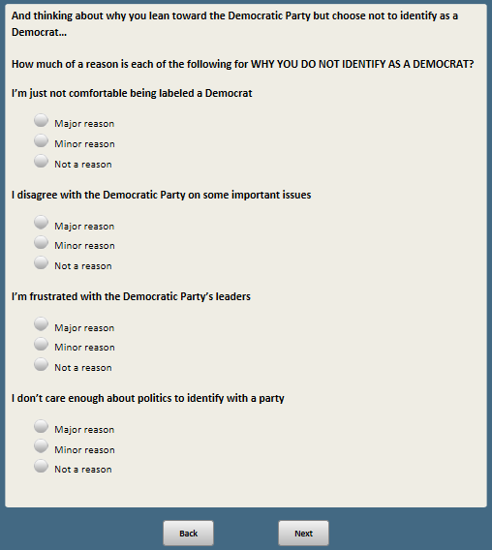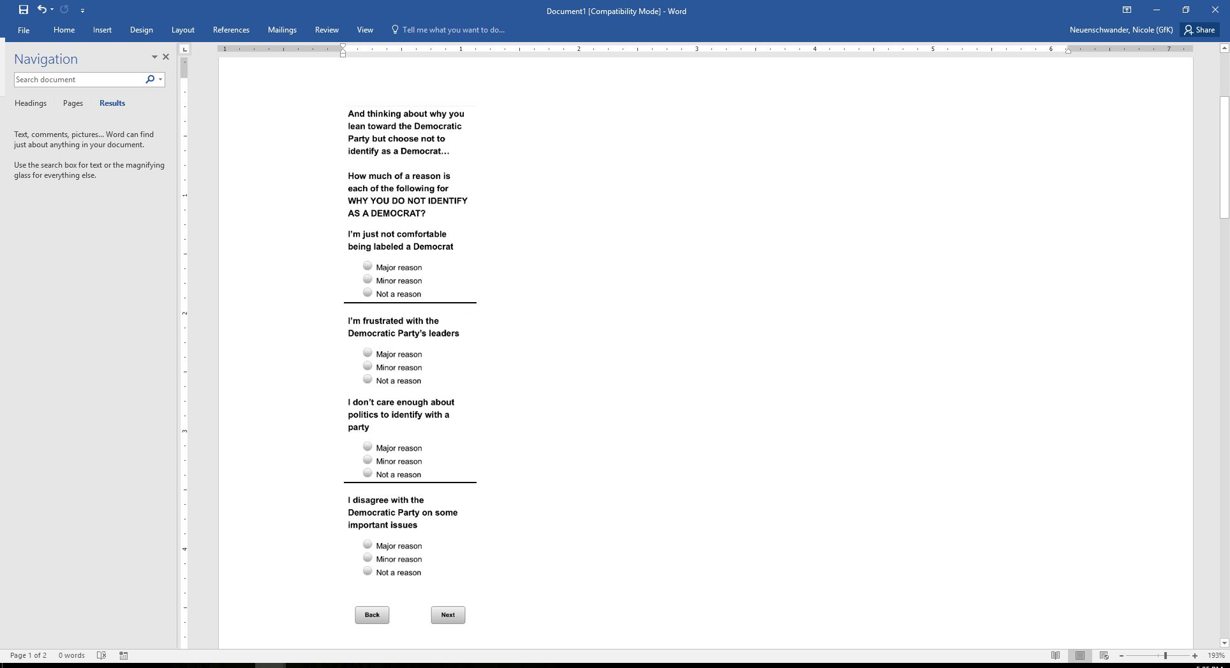

Scripter: Randomize and record order of KNOWCIV1-HOUCONTR. Always show SENCONTR and HOUCONTR next to each other (in random order)

Base: ASK ALL

*Scripter: Always show display below before first question in KNOWCIV1-HOUCONTR series*

**[DISPLAY BEFORE FIRST QUESTION IN KNOWCIV1-HOUCONTR series:** The next few questions are a little different. For each, please answer the questions as best as you can. If you don’t know the answer to a question, just move on to the next one. **[ATP ONLY:**We will reveal the correct answers at the end of the survey.]**]**

Base: ASK ALL

*Scripter: Randomize and record response options*

**KNOWCIV1 [S]**

In the case of a tied vote in the U.S. Senate, is the deciding vote cast by…

1. The vice president
2. The president
3. The Senate majority leader
4. The Senate parliamentarian

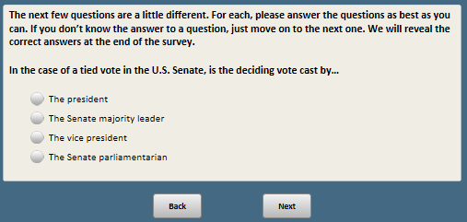

Base: ASK ALL

**KNOWCIV2 [S]**

As you may know, a filibuster in the U.S. Senate can be used to prevent legislation from coming to a vote. Of the 100 U.S. senators, how many votes are needed to end a filibuster?

1 51

2 60

3 67

4 70

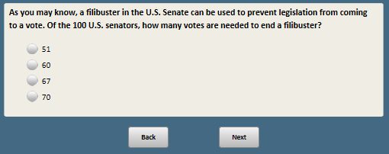

Base: ASK ALL

*Scripter: Randomize and record response options*

**KNOWCIV3 [S]**

How is the number of terms a president can serve determined?

1. Article II of the U.S. Constitution
2. Custom and precedent
3. The 22nd Amendment of the Constitution
4. There is no limit to the number of terms a president can serve

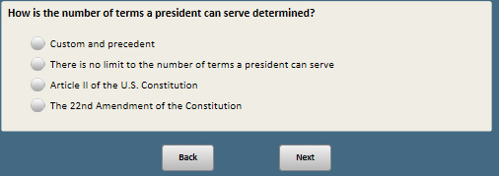

Base: ASK ALL

*Scripter: Randomize and record response options*

**KNOWCIV5 [S]**

The U.S. Electoral College…

1 Trains those who run for political office

2 Supervises the presidential debates

3 Is another name for the U.S. Congress

4 Is an assembly that formally elects the president

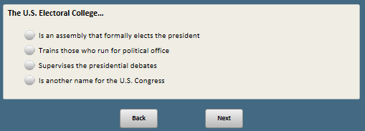

Base: ASK ALL

*Scripter: Randomize and record response options*

**KNOWCIV6 [S]**

Which of the following rights is guaranteed by the FIRST Amendment to the Constitution?

1 The right of free speech

2 The right to bear arms

3 The right to privacy

4 The right to remain silent

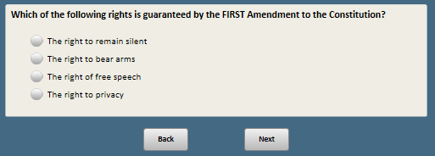

Base: ASK ALL

*Scripter: Randomize and record order of SENCONTR and HOUCONTR, always show next to each other*

*Scripter: Randomize and record response options*

**SENCONTR [S]**

Do you happen to know which political party currently has a majority in the U.S. Senate?

1 Republican Party

2 Democratic Party

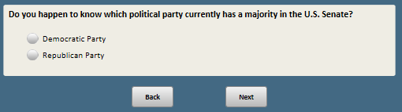

Base: ASK ALL

*Scripter: Randomize and record order of SENCONTR and HOUCONTR, always show next to each other*

*Scripter: show response in same order as SENCONTR*

**HOUCONTR [S]**

Do you happen to know which political party has a majority in the U.S. House of Representatives?

1 Republican Party

2 Democratic Party

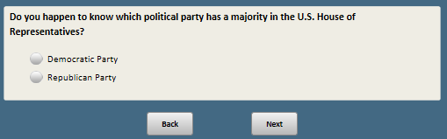

1. Open-end responses are excluded from public datasets to protect the confidentiality of ATP panelists